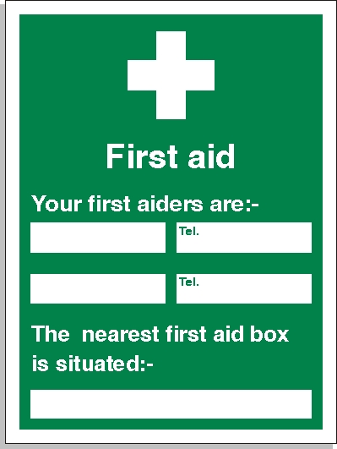****

**07711261552**

**At the Roundhouse , Hallfield Estate**

**Steve Williamson**