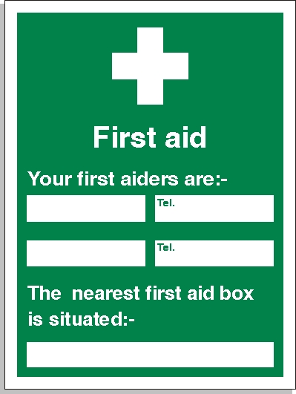****

Emergency contact number is

**0203 597 2534**

**First Aid Boxes Present in all canteens from Stratford office**

**Anderson Adjarho**