This document is to be read in conjunction with the drawings produced, which will be placed on the SHEQ notice boards. There contents will be explained during the site induction.

Project no: | HER-00080
Contract name: | Regents University
Contract address: | Regents University London, NW1 4NS
Client: | The Crown Estate
Date: | 05\09\22
Prepared by: | Max Denson
Record of amendments and issue of controlled copies
Amendment no |  | Details | Date | Initials
Circulation |  |  | Copy no
Contracts Manager |  |  | 001
Site Manager |  |  | 001
Client |  |  | 001

Description
This plan describes how the movement of traffic will be managed during the refurbishment works carried out on the project. The scope of works includes:
- Doff Cleaning
- Window repairs
- Masonry repairs
- External painting
- Scaffolding
- Use of MEWP (Mobile elevating working platforms) (Cherry Picker)
Traffic management is required on the aforementioned project to ensure the safe movement of vehicles but more importantly to ensure the Health and Safety of site personnel, the public and the users of the local street.
When planning for the delivery of materials there are many positive precautions that can be taken to ensure people outside the site are protected including:
- eliminate reversing into the street, always reverse inside of the site compound.
- all the drivers need to pay attention for pedestrian walkway route in the front of the gate once enter or exit the site compound.
- providing specific ‘drive-in’ loading areas for safer movement of goods on to site.
- plan deliveries to make sure they do not coincide with heavy pedestrian traffic, such as taking children to school.
- consider whether the deliveries should be scheduled at times outside of large movements of people such as rush hours or the journeys to and from school.

Axis site office and operative welfare facilities are located to the rear of the Acland building (SE elevation). Access for all deliveries will be via the Acland entrance (South Lodge entrance), through the electric gates that are controlled by Regents University’s Security office.
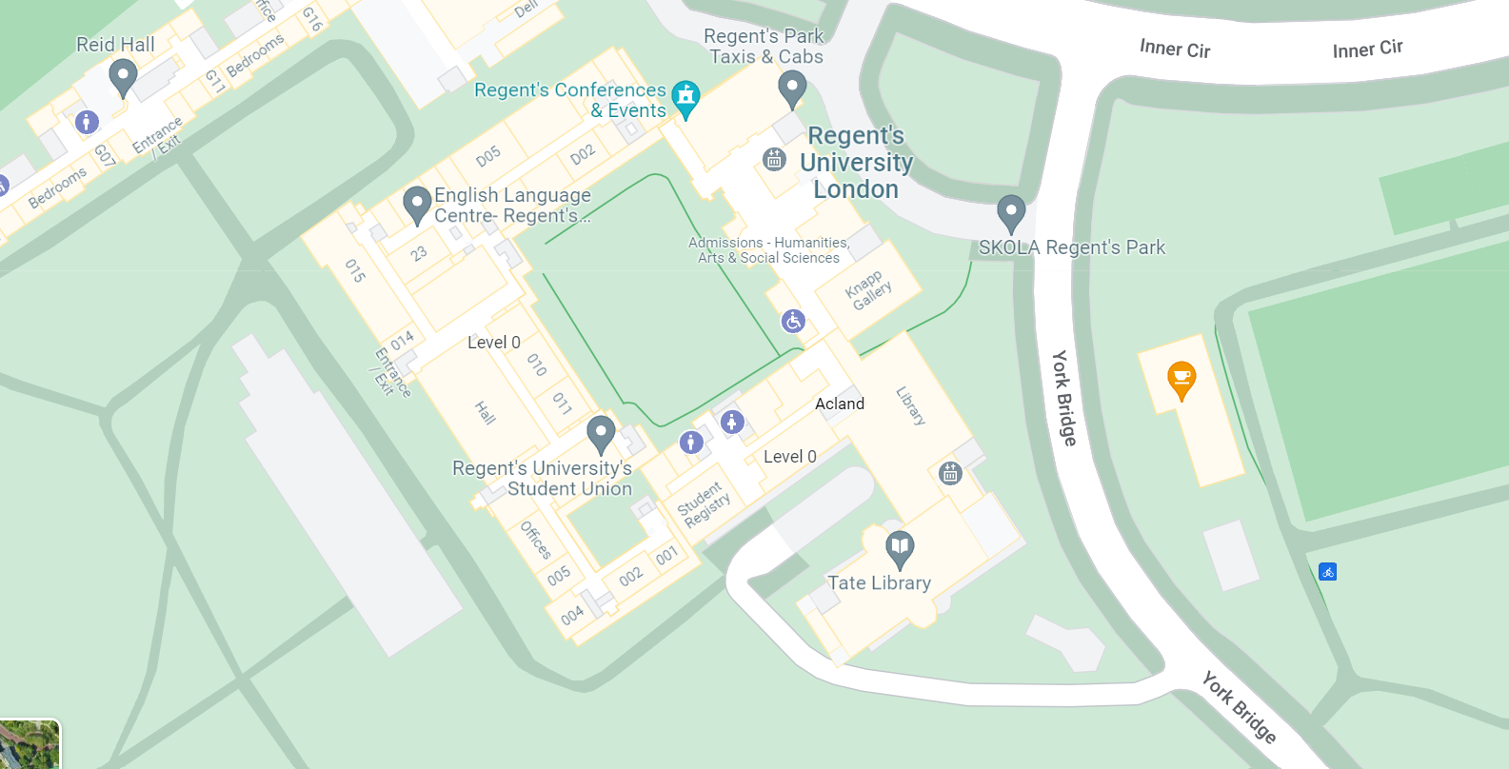
Please see map attached:

Site Office/ Welfare Facilities
Acland Entrance

Key Considerations:
It is mandatory that all site personnel and delivery drivers understand that the public will be using the footpath (in front of the Acland Entrance), and this will never be blocked by Axis subcontractors’ cars or delivery driver.
Factors that need to be taken in consideration include:
- Risk Assessment
- Ensure that all the control measures are followed
- Continuous feedback to Axis for any necessary re-appraisal of this plan
- Choice of delivery vehicle
- Appropriate certification and training certificate available.
Traffic Management
Prior to any works commencing, a site induction will be given where all relevant information shall be conveyed. This shall include information on the hazards associated with the works and the general provisions that shall be made for the protection of the public. The induction shall also include all relevant information relating to working close to the public roads and shall also include:
- Site access and egress: Via Metal Automatic gates at the Acland entrance (South Lodge entrance)
- Parking restrictions: No parking allowed in front (of the main gate), Do not obstruct Fire Assembly point at any time.
- Speed restrictions: As per public traffic signage.
- Exclusion zones.
- Access onto site and the location of the compound area; via Acland entrance
- Deliveries including delivery times; All deliveries to be agreed with Axis site management in advance, delivery times out of peak times.
- Vehicle movement, which will include loading and unloading operations along with the provision of a banks man.
- Cleanliness of the public footpaths and highway; No materials are to be stored or left into the public footpath or highway, area to be monitored and cleaner regularly.
- Site security- Electric gates at Acland entrance controlled by Regents University security office
- Protection of the public; A banksman, Barriers with signage in place, around the loading/unloading area and whilst vehicles are reversing
- Peak traffic times e.g., 08:00AM-9:00AM and 4:00PM-5:00PM;
- First aid and emergency procedures; In case of an emergency operations will be stopped immediately and right of way given if any emergency vehicle on call
Site rules:
Strictly adhere to site rules issued by Axis
Must always comply with the safety measures in place
Turn off vehicle engines whilst in the loading/unloading position, where possible to prevent excessive exhaust of fumes.
No parking or mounting of any pavement with delivery vehicles
Development
During the induction, all personnel will be briefed on the respective traffic management plan and its implementation will be explained.
Scaffold installation procedures on site:
- Vehicles need to be parked within exclusion zone/directly outside or as close to property as possible. No material storage on site.
- The subcontractor to ensure that access and egress routes are marked, and signposted and a competent person will supervise the safe movement of the vehicles, particularly when reversing manoeuvres are undertaken when on site.
- All delivered materials to the site will be stacked and arranged in an accessible manner to enable it to be unloaded or be loaded safely from the ground. If this is not possible to be sent with the regulatory fall base edge protection system as standard.
- All pedestrian footpath maintained all time. Staff to barrier off or segregates if others are working, or near the designated parking/pull-up area.
- The lorry drivers to always comply with high-visibility clothing.

Delivery and Movement of Materials

We shall ensure the minimum disruption occurs on the project due to the environment in which the works will be taking place, with particular attention being paid to the segregation of our works from that of the residents and businesses and the continuous monitoring of the increased traffic movement in the area. The delivery of materials shall be made using one vehicle at the time.
The management and control of traffic during the refurbishment works shall be of high priority and it is our intention to ensure that all pedestrian routes are demarcated and are kept free from obstruction during the works. The traffic management plan shall be updated as the works progress or if site conditions change dramatically increasing the risk to users of the highway, the public and residents.
All building materials will be delivered to the site and from there to be distributed on site via vans.
All footpaths and roads will be once again kept free from debris and safety signs will be in place warning third parties of the activities taking place

Sequence and description of vehicle movement: (inside of the site compound)
1.The delivery vehicle get in the site compound via Acland entrance
2. Once the vehicle becomes stationary, the engine will be turned off to prevent excessive exhaust of fumes and the main gate will be closed.
3. Prior to that, the delivery driver will contact the responsible person of receiving the delivery
4. Asses the location where materials will be placed, do not block at any times the pedestrian route
4. When the vehicle is ready to depart our onsite supervisor will open the gate
5. A competent person will safely oversee the vehicles and pedestrian’s movement on York Bridge. This is to ensure a safety exit from our site compound premises.
6. Site supervisor must ensure that he briefs the driver of the vehicle movement procedure
7. At no point the supervisor will manoeuvre the vehicle from behind, he must ensure that is always positioned into a safe place.

Resources
Key Personnel
Contracts Manager: | Steve Williamson
Site Manager: | Max Denson
Regional SHEQ: | Bianca Morutan
Vehicles & Plant |  | Labour | Materials
Delivery Vehicles |  | Site Manager  Tradesmen & Operatives – up to 10 nr | Building Materials
A copy is to be displayed on the SHEQ Notice Board

