23 January 2023
Scaffold Safety & Quality Requirements

- Any scaffolds that are not Basic must have a design and calculation done by a structural engineer which must be done BEFORE the scaffold erection starts
- Where the site condition require deviation from a Basic Type Scaffold, confirmation should be sought from a Structural Engineer which must confirm in writing that the structure is safe
- Make the work area safe and without risk of injury to workers, residents, general public, etc
- Do not leave materials unsupervised in the road or on the pavement
- No bombing of materials from ANY height, materials must be lowered safely using a suitable container
- No loose tubes or boards should be left leaning against any structure unattended
- Operatives must wear full PPE when carrying out scaffolding operations which must include, steel toe cap boots, hard hat, gloves, hi vis vest/jacket and they must have an Axis ID on their person, at all times whilst on site
- Operatives must wear a harness and be clipped in when working at height where a suitable collective fall measure is not in place
- Operatives must wear a harness whilst working at a height of more than 2 m and must be clipped on to the scaffold structure from a suitable point
- All scaffold access points must be created to mirror one of the below images unless there are exceptional circumstances where any deviation requires prior approval from Axis
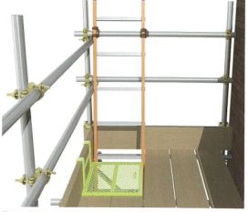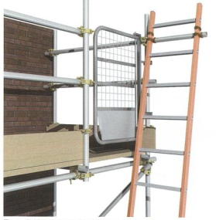
- All scaffolds that have 2 or more boarded lifts must have the ladders hatches no smaller than 450mm wide and 600mm long
- A gap of no more than 50mm should be present on all lifts and this gap must only be at the inside standard, if a service gap is required, this must be a specific requirement from Axis
- Ladders must be placed at an angle of between 65-75 degrees and be secured to the structure at both sides
- The ladders provided by yourselves must be in good condition
- Scaffolds must be tied in correctly and sufficiently to the structure or stabilised using rakers if the scaffold is no higher than 5 m (maximum 2 lifts)
- Scaffold tubes must not overhang the scaffold by more than 150mm
- Boards should overhang each end support by at least 50mm but by not more than four times the thickness of the board.
- Gyn wheels and electric hoists must have a thorough examination certificate done recording the serial number of the equipment which must be provided upon handover if it is to be used by other trades
- Joints in standards should be staggered, so that adjacent standards are not joined within the same lift level
- Joints in ledgers should be staggered, so that adjacent ledgers do not meet in the same bay
- All pavement lifts where the general public are likely to come into contact with them are to be covered in light coloured Styrofoam which is to be tied to the standards using zip ties
- All scaffolds where there is a chance of operatives, residents, the general public of walking along side it must have a fan fitted which is to be double boarded and sheeted
- All scaffolds should have signage put up which should include: scaffold company details, “no unauthorised access to scaffold”, “keep off scaffold”, “men working at height”, these signs should be visible once every 5 linear metres
- All scaffolds that span above entrances and door ways must also have a fan fitted above those areas which is also to be double boarded and sheeted
- Where the pavement lift allows operatives, residents, the general public, etc. to walk under it, this is to be double boarded and sheeted
- Safety netting, sheeting or brick guards may be needed on some scaffolds where the person in charge requests it.
- Scaffolds must be built in accordance with TG20-21 and following SG4-22, a compliance sheet must be given to the Person In Charge upon completion, on ALL basic scaffolds.
These requirements are being implemented in an attempt to reduce the number of incidents and complaints we are having. This will improve the quality of your scaffolds and the general service that you provide to Axis Europe.
Please communicate these requirements to all of your operatives

Axis Health & Safety

