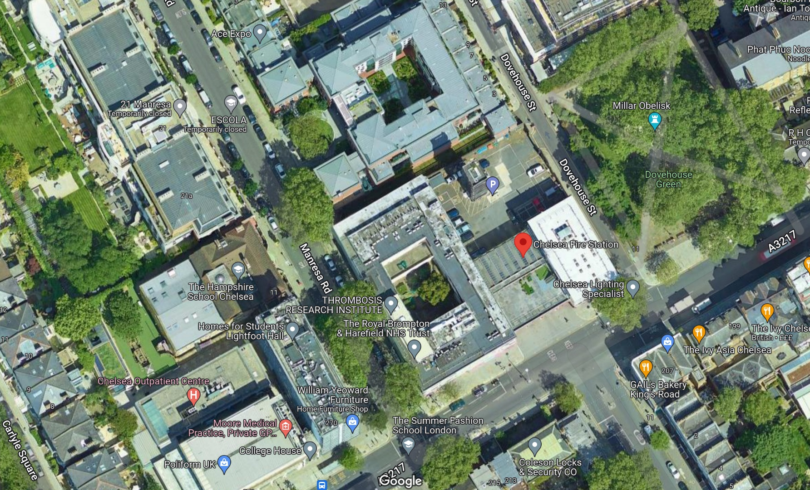
Fire Emergency Map – Chelsea Fire Station – WS002230

Site Containers / Storage

Fire Muster Point
Site Office

