
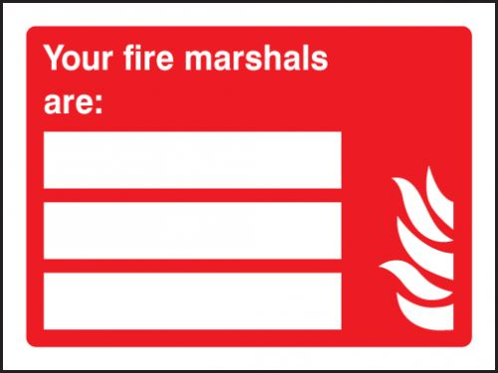

IGOR TARAN: 07596891545
NICOLA KING: 07895169870
GEORGE CAWDRON: 07944838966

