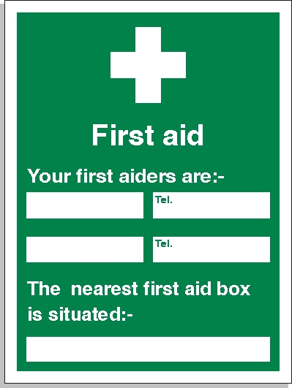

IGOR TARAN
NICOLA KING
07596891545
07895169870
Site Office

