Checklist – Fire Safety Plan

Project: | AB108 Lanark Road

The following site rules will be displayed by the Person-In-Charge (PIC) of the project within the canteen / office facilities.

Note: The PIC will, with the assistance of the Safety Advisor, insert project specific information within these rules where required (See RED italics).

 | Fire Safety Plan – Information & Requirements
 | Project Name: |  |  |  | Lanark Road
 | Organisation & Responsibilities
 | The FIRE SAFETY CO-ORDINATOR for this project is the Person-in-Charge (PIC):
 | Name |  | Igor Taran |  |  |  | Mobile Nr |  | 07596891545
 | The FIRE MARSHALL(S) for this project are:
 | Name |  | Igor Taran |  |  |  | Mobile Nr |  | 07596891545
 | Name |  | Eric Sejat |  |  |  | Mobile Nr |  | 07903124888
 | Name |  |  |  |  |  | Mobile Nr
 | Training & Induction
 | All members of the workforce will be briefed / inducted by the PIC before they commence work on site, a briefing register will be kept by the PIC on the Project Safety File.
 | Site Precautions: Arrangements for this project:
 | Detection |  |  |  | Visual, smell and smoke detectors
 | Raising the alarm |  |  |  | Fire Horn, shout “Fire 3 times” & raise building fire alarm.
 | Temporary lighting |  |  |  | N/A
 | Smoking areas: Arrangements for those who smoke:
 | Smoking is only permitted outside the building / site / working area(s) and it is banned within 3m of all buildings including welfare accommodation, offices, stores & flammable stores. Butts, matches and lighters to be disposed of in a proper manner.

Checklist – Fire Safety Plan / Continued

 | Hot Works: Arrangements for permits to works:
 | A formally documented procedure designed to provide additional safeguards for the specified activities will be operated, all package contractors will be required to comply and their works will not commence without a permit being in place. Permits are obtainable from the PIC.
 | Temporary Buildings & Accommodation: Arrangements for this project:
 | The following temporary buildings and accommodation will be provided:
 | Welfare |  | Axis Site Compound, Brinklow House, Torquay Street, London, W2 5EN  Mobile unit at Thurso House, NW6 5EN
 | Offices |  | Axis Site Compound, Brinklow House, Torquay Street, London, W2 5EN  Mobile unit at Thurso House, NW6 5EN
 | Storage |  | Axis Site Compound, Brinklow House, Torquay Street, London, W2 5EN
 | Emergency Procedures: Arrangements for this project:
 | Raising the alarm |  | You must alert the fire marshal (either in person or by mobile phone), your workmates and anyone else in the vicinity.
 | Fighting the fire |  | You may attempt to use a fire extinguisher to put out the fire, but only if you have been trained in its use and you do not put yourself or others at risk in doing so.
 | Evacuating the site |  | If the alarm is sounded the workforce and any visitors must leave the site by the escape routes and exits which are clearly marked on the site plan displayed in the rest facilities. You must not stop to collect tools, equipment and personal items and may only attempt to render assistance to others if you do not put yourself or others at risk in doing so.
 | Muster Point |  | After leaving the site you must assemble at the muster point. You must stay at the muster point and must not attempt to re-enter the site until you are advised by the PIC that it is safe to do so. You must not leave to go home without informing the PIC.
 | Location of the Muster Point |  | The Muster Point is located at: Corner of Lanark road and Sutherland Avenue
 | Calling the Brigade |  | In the event of an emergency the PIC will be responsible for calling the Brigade.
Checklist – Fire Safety Plan / Continued

 | Fire Brigade access, facilities, liaison & co-ordination: Arrangements:
 | Access |  | Access for the Brigade will be via: Sutherland Avenue/ Lanark Road or Elgin Ave/Lanark Road
 | Fire fighting shafts |  | Fire fighting shafts are located at: N/A
 | Fire lifts |  | Fire lifts are located at: N/A
 | Temporary hoists |  | Temporary hoists are located at: N/A
 | Dedicated routes |  | Dedicated escape routes are located at:
 | Sprinklers |  | Sprinkler installations serve the following floor(s)/area(s): N/A
 | Floor loadings |  | The following loading limitations apply: N/A
 | Dry risers |  | Dry riser inlets are available at: N/A
 | Wet risers |  | Wet riser inlets are available at: N/A
 | Fire points |  | Fire points are available at: site compound.
 | Temporary buildings |  | Temporary building and accommodation are located at: Axis Site Compound, Brinklow House, Torquay Street, London, W2 5EN
 | Hazardous items |  | Flammable liquids are stored at:  N/A  Gas cylinders are stored at:  N/A  Gas mains are present at the following locations:  Isolated gas supply to kitchen  Electrical risers are present at the following locations:  N/A  Temporary holes in floor slabs are located at:  N/A
 | Co-ordination |  | The PIC will be responsible for liasing with the Senior Officer.

Checklist – Fire Safety Plan / Continued

 | Security measures to prevent Arson: Arrangements for this project:
 | Signing in / out |  | You must sign in when starting work and sign out when finishing. The register will be kept in the office or designated welfare area by the PIC; this will also apply if there is a need to leave the site for any reason.
 | Access points |  | You must only enter the site via the designated access points and must play your part in ensuring the gates and doors to work and storage areas, compounds or cages are properly secure at all times, particularly at meal breaks, to prevent unauthorised access.
 | Special measures |  | N/A
 | Materials storage: Arrangements for this project:
 | Allocation of space |  | The PIC will allocate space within the working area(s) or compound for the storage of materials. Premature delivery and storage of unreasonable quantities of potentially flammable materials will not be permitted.
 | Flammable liquids and gases generally |  | The PIC must be informed of flammable liquids or gases to be brought onto and stored on site.
 | Flammable gases |  | Contractors, sub-contractors and others are to provide the appropriate secure cages for on-site LPG and gas storage, or they must arrange for cylinders to be brought to and taken away from site on a daily basis. Cages are to be placed on a clean, dry and level hardstanding with appropriate warning signage and kept free of flammable waste, rubbish and weeds.
 | Flammable liquids |  | Contractors, sub-contractors and others are to store flammable liquids in bunded areas with a 10% safety factor. In the event of this not being possible or appropriate they shall provide fire-resistant stores, cupboards or bins and in this case the storage of flammable liquids is to be strictly limited to a maximum of 50 litres or a half-days supply whichever is the least. All storage facilities are to have appropriate warning signage.
 | Waste control: Arrangements for this project:
 | General provisions |  | Skips will be provided for the collection and removal of waste. The workforce is to ensure all debris or waste is bagged and cleared at the end of the day or shift and their working areas are kept tidy. The burning of debris or waste on site or within skips is forbidden.
 | Specific provisions
Checklist – Fire Safety Plan / Continued

 | Monitoring & Compliance: The PIC will monitor all requirements of the Site Fire Plan, paying special attention to the following:
 | Briefing/Induction – as required |  | The PIC will update and brief the workforce (& new members) where changes is procedures / working methods or configuration of the site require it
 | Hot Works & Permit Arrangements - continuous |  | Compliance with PTW arrangements. Will issue permits All unauthorised or non-compliant works by any member of the workforce will be stopped immediately. No hot works are to be carried out during the period of two hours before the end of the working day or shift.
 | Fire extinguishers & alarms - weekly |  | All those carrying out hot works of any kind are to ensure they have an extinguisher in the immediate vicinity.
 | Access / egress & escape routes & working areas - weekly |  | High standards of housekeeping are expected, all routes and working areas are to be kept from of waste, debris of flammable materials all of which is to be removed to the skips or from site on a regular basis.

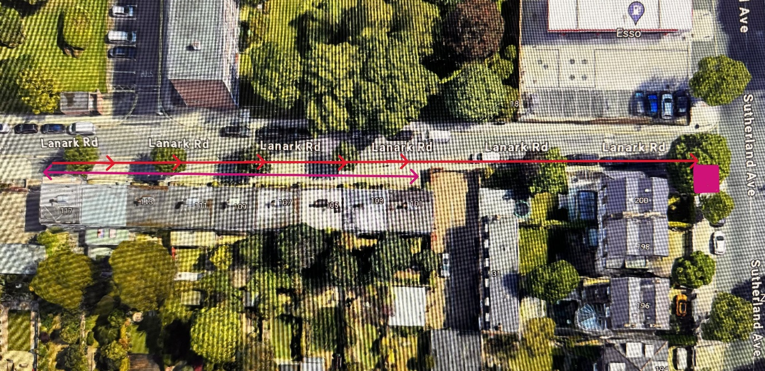

Key: Site location

Escape routes

Assembly point

We the undersigned confirm we have been briefed by the Person-in-Charge (PIC) and we understand the requirements of the SITE FIRE PLAN

 | Name (print) |  | Company |  | Signature |  | Date

