
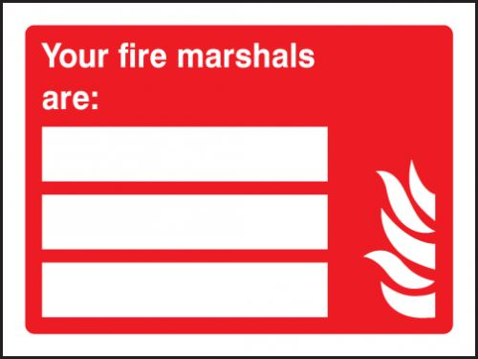

Razvan Dumitriu
-07850192796
Cameron Bonthron
-07725869337

