
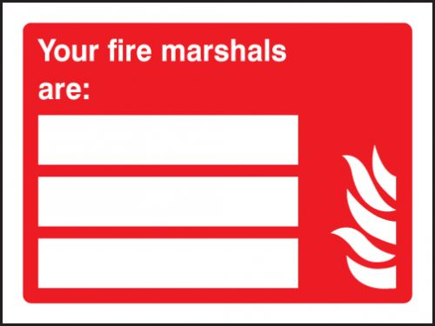

Rob James
-07968 738 999
Kemara Brown
- 07934 422 905

