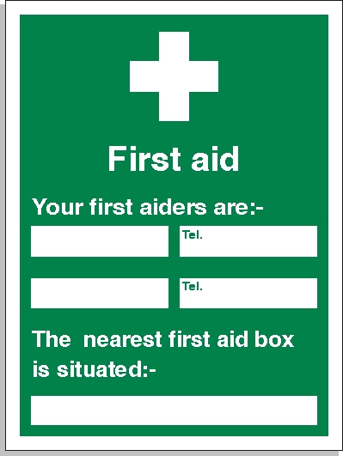

Razvan Dumitriu
Steve Harpley
07850192796
07413839457
Site Office

