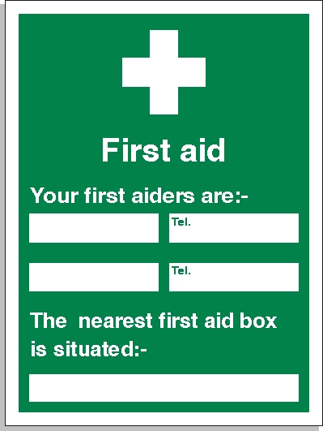

Rob James
Kemara Brown
07968 738999
07934 422905
Site Office

