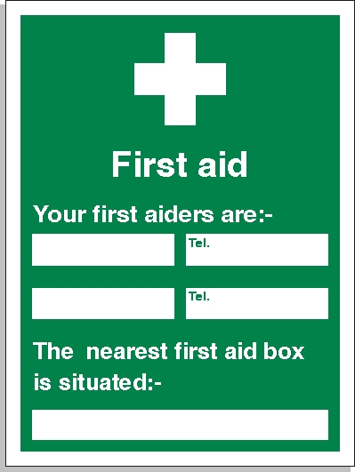

Rian Sillett
07725 190933
Site Office
Laurence Austin
07931 537022

