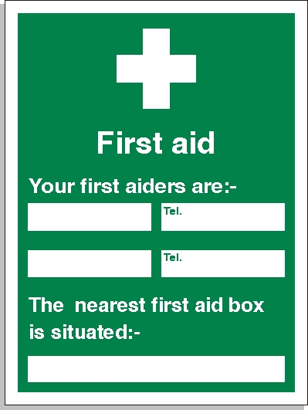

Elliot Munnelly
Steven Lawrence
078172912572
07852353277
Site Office

