**This document is to be read in conjunction with the drawings produced, which will be placed on the SHEQ notice boards. There contents will be explained during the site induction.**

|  |  |  |  |  |
| --- | --- | --- | --- | --- |
| **Project no:** | ? | | | |
| **Contract name:** | Dorset House | | | |
| **Contract address:** | Dorset House, Gloucester Place, NW1 5AG | | | |
| **Client:** | Dorset House Residential Ltd | | | |
| **Date:** | 9/12/2024 | | | |
| **Prepared by:** | Stephen Taylor | | | |
|  | | | | |
| **Record of amendments and issue of controlled copies** | | | | |
| **Amendment no** | | **Details** | **Date** | **Initials** |
|  | |  |  |  |
|  | |  |  |  |
|  | | | | |
| **Circulation** | | | **Copy no** | |
| Contracts Manager | | | 001 | |
| Site Manager | | | 002 | |
| Client | | | 003 | |

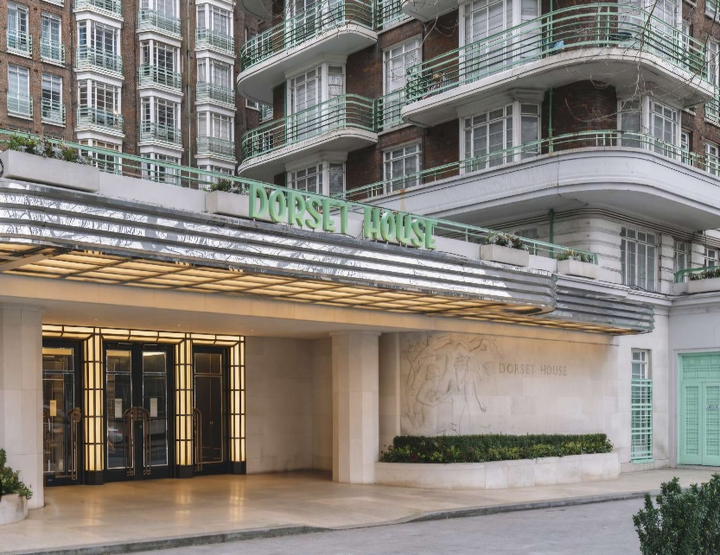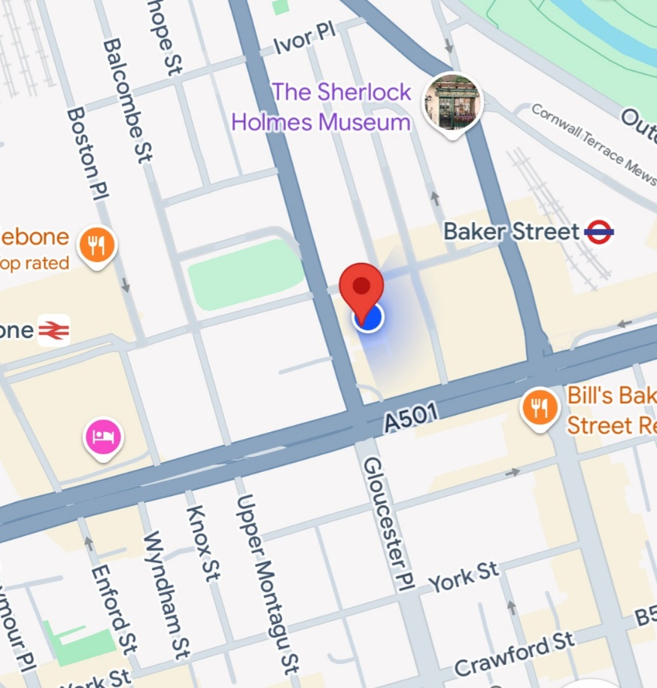**Site Location – Dorset House**

Dorset House is located in Gloucester Place, MW1 5AG.

The site office is located on the ground floor of tower 1, the welfare is located on the ground floor of tower 4.

The RLO office is the same as the site office on the ground floor of tower 1.

**Description**

This plan describes the site logistics and how the movement of traffic will be managed during building works at Dorset House.

The scope of works for the project includes:

* New Front entrance doors
* New Communal lighting
* New tv and internet fibre cables
* New Carpets
* Decorations

**Traffic Management**

Traffic management is required for material deliveries only.

**When planning for the delivery of materials** there are many positive precautions that can be taken to ensure people outside the site are protected including:

* All delivery slots must be pre - booked with the Site team before entering and delivering to site, this must be arranged 48 hours prior to delivery.
* Planned deliveries with 48 hour notice will be passed on to the front reception at Dorset House.
* The client has requested that all deliveries must take place in the designated area at the front of Dorset House.
* Vehicles must enter via Gloucester Place.
* Delivery drivers must report to site office located on the ground floor of tower 1.
* Drivers must take extra care when driving into the entrance and have a banksman present when entering the driveway.
* Once vehicles reach site they must park in the designated loading bay, a traffic banksman must be always present to monitor vehicles movements on arrival, for unloading and departure from site.

**Proposed Vehicle Route**

**Vehicle Entrance**

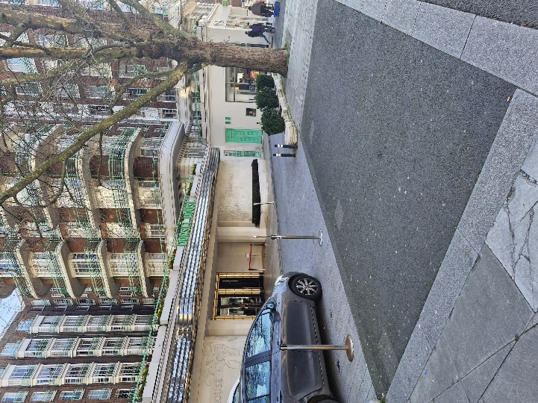All Vehicles to enter via Gloucester Place.

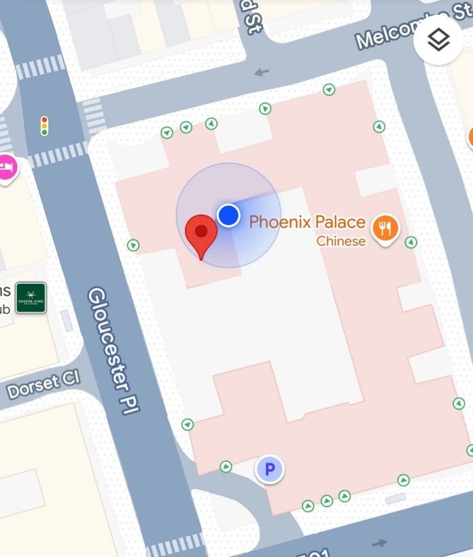**Designated Route**

This image shows the entrance from Gloucester Place.

**Designated loading bay**

The picture to my left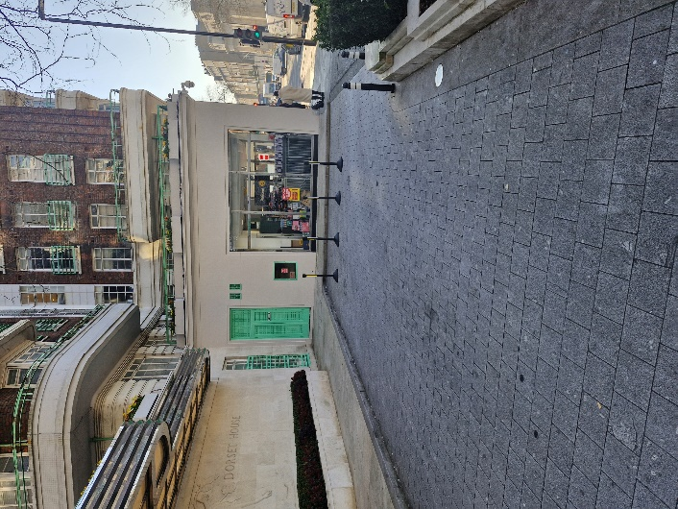 shows the loading bay for deliveries. Chapter 8 barriers need to be used to segregate pedestrians from deliveries.

**Key Considerations:**

This plan highlights the considerations trade contractors need to take when having goods delivered or collected from site; hence it will affect all trade contractors.

It is paramount that all site personnel and delivery drivers understand that the public will be using the footpaths where loading/unloading will happen and that the procedures highlighted in this document shall be adhered to for the safety of all concerned.

Access for loading will be when entering from Gloucester Place in the marked out bay as seen in the designated loading bay above.

All deliveries will require Dedicated traffic banksman.

These considerations include:

* Risk Assessments
* Ensure control measurements are followed.
* Continuous feedback to Axis for any necessary re-appraisal of this plan
* Choice of delivery vehicle
* Appropriate certification and training certificate available.

**Health & Safety Legislation and Guidance**

The key legislation and guidance in respect to traffic management and logistics includes:

**Key Legislation**

• Health and Safety at Work Act  
• Construction Design & Management Regulations  
• Provision and Use of Work Equipment Regulations  
• Health & Safety (Safety Signs & Signals) Regulations  
• Management of Health & Safety at Work Regulations

**Key Guidance**  
• The Safe Use of Vehicles on Construction Sites [HS(G)144]  
• Protecting the Public - Your next Move [HS(G)151]  
• Workplace transport safety - [HS(G)136]  
• Managing vehicle safety at the workplace – INDG 199

**Traffic Management**

Prior to any works commencing a site induction will be given where all relevant information shall be conveyed. This shall include information on the hazards associated with working in a live environment and the general provisions that shall be made for the protection of the public. The induction shall also include all relevant information relating to working close to the public highway and shall also include:

* Site access and egress: Enter Dorset House Via Gloucester Place.
* Parking restrictions: No parking allowed in resident bays.
* Speed restrictions; As per public traffic signage.
* Exclusion zones; N/A
* Access onto site and the location at Dorset House.
* Deliveries including delivery times; All deliveries to be agreed with Axis site management in advance, delivery times out of peak times.
* Vehicle movement, which will include loading and unloading operations along with the provision of a banks man.
* Cleanliness of the public footpaths and highway; No materials are to be stored or left into the public footpath or highway, area to be monitored and cleaner regularly.
* Site security and signage; Signage will be placed on barriers warning public to keep clear.
* Protection of the public; Barriers with signage in place, around the loading/unloading area and whilst vehicles are entering and exiting Dorset House.
* Peak traffic times e.g. 0800 hrs and 1600hrs
* First aid and emergency procedures; In case of an emergency operations will be stopped immediately and right of way given if any emergency vehicle on call (lights and/or sirens in operation).

**Site rules:**

Strictly adhere to site rules issued by Axis.

Must always comply with the safety measures in place.

Turn off vehicle engines whilst in the loading/unloading position, where possible to prevent excessive exhaust of fumes.

No parking or mounting of any pavement with delivery vehicles.

During the induction all personnel will be briefed on the respective traffic management plan and its implementation will be explained.

**Delivery and Movement of Materials**

We shall ensure the minimum disruption occurs on the project due to the environment in which the works will be taking place, with particular attention being paid to the segregation of our works from the public and continuous monitoring any traffic movement in the area. The delivery of materials shall be made using the minimum number of vehicles.

The management and control of traffic during the works shall be of high priority and it is our intention to ensure that all pedestrian routes are demarcated and are kept free from obstruction during the works. The traffic management plan shall be updated as the works progress or if site conditions change dramatically increasing the risk to users of the highway, the public and residents.

All building materials will be delivered to the site at Dorset House.

Waste collection will be done using a weight and load and the area will be segregated using barriers with signage to prevent public coming in contact. All footpaths and roads will be once again kept free from debris, materials and tools and safety signs will be in place warning third parties of the activities taking place.

**Sequence and description of vehicle movement and unloading of materials.**

1.The delivery vehicle will drive into Dorset House after coming off of Gloucester Place and park in the designated loading bay directed by the traffic banksman.

2. Once the vehicle becomes stationary, the engine will be turned off to prevent excessive exhaust of fumes.

3. Chapter 8 barriers will segregate the loading bay from the public and clear signage warning pedestrians of movements on site.

4. The nominated banksman will monitor the delivery process to ensure the safety of the public and workers whilst materials are moved to and from site.

5. When the delivery is complete the traffic banksman will ensure the delivery vehicle departs site in a safe manner onto the designated route.

6.. At no point will the banks man will manoeuvre the vehicle from behind, he/she must ensure that is always positioned into a safe place.

7. At the end of delivery the banksman & site team will remove all temporary barriers and signage and ensure the area is clear of debris.

**Site Logistics**

Site Plan and set up.

1. Axis are to liase with Dorset House front desk and allow them 48 hour notice prior to deliveries and wait and loads.

2. No skips on site. All rubbish will be removed from site using wait & load trucks.

3. Designated material storage will be within the storage areas within Dorset House.

4. No materials to be stored outside of the site boundary.

5. All exit routes must be always kept clear.

6. Pedestrian routes in and out of the building to be always kept clear.

7. Careful consideration is to be taken when waste is transferred from within the building onto the wait and load lorry.

8. Any combustible waste materials shall be disposed of off-site as soon as practicable and shall not be stored other than in non-combustible containers and away from any other combustible materials or oxidising agents.

**Welfare Facilities**

1. A Welfare facility will be provided on the ground floor of tower 4, providing washing facilities, drinking water, a place to eat.
2. Changing facilities will be provided within the welfare area on the ground floor of tower 4.
3. RLO will be situated within the site office on the ground floor of tower 1.
4. A site office will be situated on the ground floor of tower 1.

**Resources**

|  |  |  |  |
| --- | --- | --- | --- |
| **Key Personnel** | | | |
| **Contracts Manager:** | Steven Lawrence | | |
| **Site Manager:** | Stephen Taylor | | |
| **Regional SHEQ:** |  | | |
| **Banksman:** | Trained Banksman TBC | | |
|  | | | |
| **Vehicles & Plant** | | **Labour** | **Materials** |
| Skip Wagon  Weight and load  Delivery Vehicles | | Site Manager  Tradesmen & Operatives | Building Materials |
| **A copy is to be displayed on the SHEQ Notice Board** | | | |