
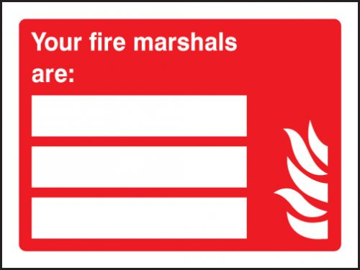

Stephen Taylor
07549 949332
Lynda Prentice
07919 153972

