**This document is to be read in conjunction with the drawings produced, which will be placed on the SHEQ notice boards. There contents will be explained during the site induction.**

|  |  |  |  |  |
| --- | --- | --- | --- | --- |
| **Project no:** | ? | | | |
| **Contract name:** | Sutton Housing partnership | | | |
| **Contract address:** | Rosehill Court, Morden | | | |
| **Client:** | Sutton Housing Partnership | | | |
| **Date:** | ? | | | |
| **Prepared by:** | Matthew Wilson | | | |
|  | | | | |
| **Record of amendments and issue of controlled copies** | | | | |
| **Amendment no** | | **Details** | **Date** | **Initials** |
|  | |  |  |  |
|  | |  |  |  |
|  | | | | |
| **Circulation** | | | **Copy no** | |
| Contracts Manager | | | 001 | |
| Site Manager | | | 002 | |
| Client | | | 003 | |

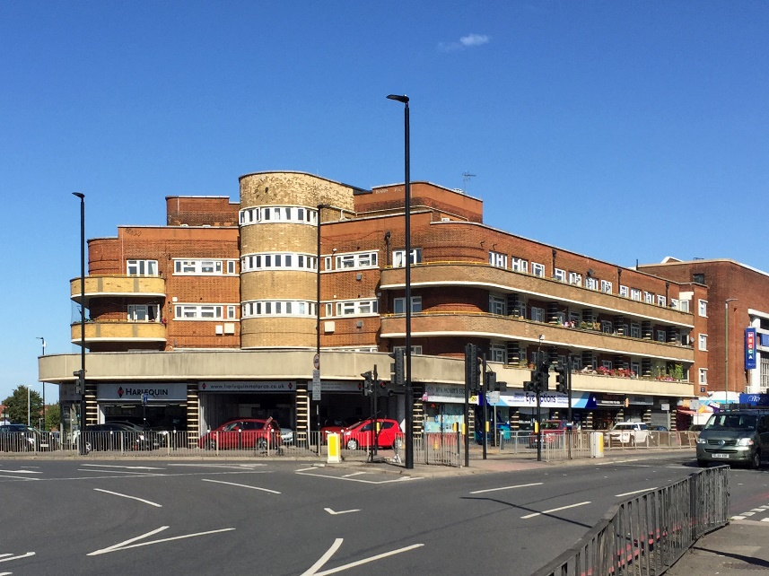**Site Location – Rosehill Court**

Rosehill court is located on St Hellier Avenue and is situated in Sutton, SM4 6JT

The site office and welfare for contractors will be Commercial units 2,3 and 4 underneath the residential properties at Rosehill Court.

The RLO office will be in Flat 44A and Site respite room will be located in flat 49 both of which on the second floor.

Please note that the site is a one way only permitted route as will be shown further in the document.

**Description**

This plan describes the site logistics and how the movement of traffic will be managed during building works Rosehill court.

The scope of works for the project includes:

* Scaffolding
* Masonry repairs
* Roof works
* Internal repairs
* M and E works
* Decorations

**Traffic Management**

Traffic management is required on the aforementioned project to ensure the safe movement of vehicles but more importantly to ensure the Health and Safety of site personnel, the public and the users of the park.

**When planning for the delivery of materials** there are many positive precautions that can be taken to ensure people outside the site are protected including:

* All delivery slots must be pre - booked with the Sutton Housing partnership team before entering and delivering to site, this must be arranged 48 hours prior to delivery or if arranged with the contracts or site manager a year pass can be given to cover the entirety of the project the details needed for this would be vehicle registration , make, model and colour to avoid fines and complaints.
* Plan deliveries with 48 hour notice or with the vehicle pass to make sure they do not coincide with heavy pedestrian traffic, such as taking children to school. However a vehicle delivery plan will be submitted to Sutton housing partnership to highlight when these deliveries are made.
* The client has requested that all deliveries must take place in the designated parking/loading/ unloading bay to the left of the wall (as seen in the designated loading bay image below) directly behind the Mecca bingo hall and should never take place in the residential parking bays.
* Vehicles must enter via St Hellier Avenue and into Rosehill court in which they can park, load and unload behind the bingo hall, then exit via the A217 making the entrance and exit routes one way at all times .
* Delivery drivers must drive along the designated route at all times.
* Drivers must take extra care when driving through Rosehill court with prominent signage at the rear of the vehicle to warn cyclists/pedestrians of the dangers of passing the vehicle.
* Audible alert to other road users to the planned movement of the vehicle’s indicators are in operation.
* Once vehicles reach site they must park in the designated loading bay, a traffic banksman must be always present to monitor vehicles movements on arrival, for unloading and departure from site.

**Proposed Vehicle Route**

**Vehicle Entrance**

All Vehicles to enter via St Hellier avenue into Rosehill court

**Designated Route**

Vehicles to follow designated route as shown in image.

This will be a one way route at all times as to be followed in the image to the left.

**Designated loading bay**

The picture to my left shows the designated loading bay area which is situated to the left of the wall behind the Mecca bingo hall on site, ensuring that no vehicles are parked directly behind the Mecca bingo hall. On arrival to site vehicles will be directed by the traffic banksman into the designated loading bay Highlighted in blue in the image to the left. Chapter 8 barriers will segregate the public from the off-loading of materials.

**Key Considerations:**

This plan highlights the considerations trade contractors need to take when having goods delivered or collected from site; hence it will affect all trade contractors.

It is paramount that all site personnel and delivery drivers understand that the public will be using the footpaths where loading/unloading will happen and that the procedures highlighted in this document shall be adhered to for the safety of all concerned.

Access for loading will be when entering from Saint Hellier Avenue into Rose Hill Court and parked behind the Mecca Bingo hall in the marked out bay as seen in the designated loading bay above.

There will be no reversing permitted and drivers must adhere to the one way route which will be stated in signage and shown by the traffic banksman.

These considerations include:

* Risk Assessments
* Ensure control measurements are followed.
* Continuous feedback to Axis for any necessary re-appraisal of this plan
* Choice of delivery vehicle
* Appropriate certification and training certificate available.

**Health & Safety Legislation and Guidance**

The key legislation and guidance in respect to traffic management and logistics includes:

**Key Legislation**

• Health and Safety at Work Act  
• Construction Design & Management Regulations  
• Provision and Use of Work Equipment Regulations  
• Lifting Operations and Lifting Equipment Regulations  
• Health & Safety (Safety Signs & Signals) Regulations  
• The New Roads and Street works Act  
• Management of Health & Safety at Work Regulations

**Key Guidance**  
• The Safe Use of Vehicles on Construction Sites [HS(G)144]  
• Protecting the Public - Your next Move [HS(G)151]  
• Workplace transport safety - [HS(G)136]  
• Managing vehicle safety at the workplace – INDG 199

**Traffic Management**

Prior to any works commencing a site induction will be given where all relevant information shall be conveyed. This shall include information on the hazards associated with working in a live environment and the general provisions that shall be made for the protection of the public. The induction shall also include all relevant information relating to working close to the public highway and shall also include:

* Site access and egress: St Hellier avenue and exit from Rose hill court onto the A217
* Parking restrictions: No parking allowed in resident bays.
* Speed restrictions; As per public traffic signage.
* Exclusion zones; N/A
* Access onto site and the location at Rosehill court
* Deliveries including delivery times; All deliveries to be agreed with Axis site management in advance, delivery times out of peak times.
* Vehicle movement, which will include loading and unloading operations along with the provision of a banks man.
* Cleanliness of the public footpaths and highway; No materials are to be stored or left into the public footpath or highway, area to be monitored and cleaner regularly.
* Site security and signage; Signage will be placed on barriers warning public to keep clear.
* Protection of the public; Barriers with signage in place, around the loading/unloading area and whilst vehicles are executing the 3-point turn.
* Peak traffic times e.g. 0800 hrs and 1600hrs
* First aid and emergency procedures; In case of an emergency operations will be stopped immediately and right of way given if any emergency vehicle on call (lights and/or sirens in operation).

**Site rules:**

Strictly adhere to site rules issued by Axis.

Must always comply with the safety measures in place.

Turn off vehicle engines whilst in the loading/unloading position, where possible to prevent excessive exhaust of fumes.

No parking or mounting of any pavement with delivery vehicles.

During the induction all personnel will be briefed on the respective traffic management plan and its implementation will be explained.

**Delivery and Movement of Materials**

We shall ensure the minimum disruption occurs on the project due to the environment in which the works will be taking place, with particular attention being paid to the segregation of our works from the public and continuous monitoring any traffic movement in the area. The delivery of materials shall be made using the minimum number of vehicles.

The management and control of traffic during the works shall be of high priority and it is our intention to ensure that all pedestrian routes are demarcated and are kept free from obstruction during the works. The traffic management plan shall be updated as the works progress or if site conditions change dramatically increasing the risk to users of the highway, the public and residents.

All building materials will be delivered to the site at Rosehill Court.

Waste collection will be done using a weight and load and the area will be segregated using barriers with signage to prevent public coming in contact. All footpaths and roads will be once again kept free from debris, materials and tools and safety signs will be in place warning third parties of the activities taking place.

**Sequence and description of vehicle movement and unloading of materials.**

1.The delivery vehicle will drive into Rosehill court after coming off of St Hellier Avenue and park in the designated loading bay directed by the traffic banksman.

2. Once the vehicle becomes stationary, the engine will be turned off to prevent excessive exhaust of fumes.

3. Chapter 8 barriers will segregate the loading bay from the public, the pathway directly behind the bingo hall will be temporarily closed off for the duration of the delivery using barriers and clear signage warning pedestrians of movements on site.

4. The nominated banksman will monitor the delivery process to ensure the safety of the public and workers whilst materials are moved to and from site.

5. When the delivery is complete the traffic banksman will ensure the delivery vehicle departs site in a safe manner onto the designated route.

6.. At no point will the banks man will manoeuvre the vehicle from behind, he/she must ensure that is always positioned into a safe place.

7. At the end of delivery the banksman & site team will remove all temporary barriers and signage and ensure the area is clear of debris.

**Site Logistics**

Site Plan and set up.

1. The site will follow a strict one way policy as shown in the designated route above and will be adhered to at all times.

2. There will be clear and precise signage to show the access and egress routes and also the one way route that will be maintained and implemented for the entirety of the project.

3. Axis are to liase with Sutton housing partnership and allow them 48 hour notice or a year pass prior to deliveries and wait and loads, all deliveries and wait and loads should be completed in the loading bay behind the Mecca bingo hall.

5. No skips on site. All rubbish will be removed from site using wait & load trucks.

6. Designated material storage will be within the site office in commercial unit 2,3 and 4.

7. No materials to be stored outside of the site boundary.

8. All exit routes must be always kept clear.

9. Pedestrian routes in and out of the building to be always kept clear.

10. Careful consideration is to be taken when waste is transferred from within the building onto the wait and load lorry.

11. Any combustible waste materials shall be disposed of off-site as soon as practicable and shall not be stored other than in non-combustible containers and away from any other combustible materials or oxidising agents.

**Welfare Facilities**

1. A Welfare facility will be provided on the ground floor of the commercial unit 2,3 and 4 providing washing facilities, drinking water, a place to eat.
2. Changing facilities will be provided within units 2,3 and 4.
3. Flat 44A will be the sites RLO office.
4. Flat 49 will be available as a site respite flat and will be available for the residents at Rosehill court.
5. Client to clear rooms of personal belongings before works commence.
6. A site office will be situated on the ground floor of commercial unit 2,3 and 4.

**Resources**

|  |  |  |  |
| --- | --- | --- | --- |
| **Key Personnel** | | | |
| **Contracts Manager:** | Steve Williamson | | |
| **Site Manager:** | Matthew Wilsom | | |
| **Regional SHEQ:** |  | | |
| **Banksman:** | Trained Banksman TBC | | |
|  | | | |
| **Vehicles & Plant** | | **Labour** | **Materials** |
| Skip Wagon  Weight and load  Delivery Vehicles | | Site Manager  Tradesmen & Operatives | Building Materials  Scaffold |
| **A copy is to be displayed on the SHEQ Notice Board** | | | |