This document is to be read in conjunction with the drawings produced, which will be placed on the H&S notice boards. There contents will be explained during the site induction.

Project no: | Com-00183
Contract name: | Vittoria school, Phase 2
Contract address: | Axis Site Compound, Brinklow House, Torquay Street, London, W2 5EN
Client: | Islington Council
Date: | 20/03/2025
Prepared by: | Tom Ratcliff
Record of amendments and issue of controlled copies
Amendment no |  | Details | Date | Initials
Circulation |  |  | Copy no
Contracts Manager |  |  | Robert Walker
Site Manager |  |  | Tom Ratcliff
Client |  |  | Islington Council

Contents

- Introduction
  - General Scope
  - Site Location
  - Key Considerations

- Health & Safety Legislation and Guidance

- Key Aspects of the Plan
3.1 Site security and signage
3.2 Site access and egress
3.3. Restrictions
3.4 Separation of Pedestrians and Vehicles
3.5 Vehicle and Plant Routes
3.6 Control measures
3.7 Loading and Unloading
3.8 Storage
3.9 Public Protection for vehicle deliveries to projects
3.10 Procedures for working from a lorry
3.11 Information for Suppliers and Transporter
3.12 Interface with Hoist/Cranes
3.13 Vehicle Selection

- Key roles and responsibilities
- Risk Register

Appendices:

Appendix 1 – Maps to and around site

Appendix 2 – Routing of crane and Construction Vehicles

Appendix 3 – Delivery Driver Site rules
- Appendix 4 - Compulsory driver briefing on entrance to site

- Introduction

Traffic management is required on the aforementioned project to ensure the safe movement of plant and vehicles but more importantly to ensure the Health and Safety of site personnel, the general public and the users of the local highway.
Every year people are killed or injured by vehicles at work. This document provides practical guidance on the planning of these issues, the control measures that will be implemented and highlights the points for consideration and necessary actions.
Avoiding hazards and controlling the risks arising from the use of the vehicles in construction work is essential. The Health and Safety Executive (H.S.E.) expect to see traffic management plans that include:
• Planning and managing both vehicles and pedestrian movements
• The elimination of reversing where possible
• Safe driving and working practices
• Protection of the public
• Adequate vision and lines of sight
• The provision of signs and barriers
• Adequate parking and off-loading / storage areas
If you require further information on this topic, please contact the Health and Safety Manager. You can obtain a free leaflet from the H.S.E. website on www.hse.gov.uk/pubns/indg199.pdf
We shall ensure the minimum disruption occurs on the project due to the environment in which the works will be taking place, with particular attention being paid to the segregation of our works from that of the local residents and businesses and the continuous monitoring of the increased traffic movement in the area. Site personnel’s vehicles shall be securely parked during working hours and the delivery of materials shall be made using the minimum number of vehicles.
The management and control of traffic during EWI works shall be of high priority and it is our intention to ensure that all pedestrian routes are demarcated and are kept free from obstruction during the works. The traffic management plan shall be updated as the works progress or if site conditions change dramatically increasing the risk to users of the highway, the general public and local residents.
Building materials can be delivered to the site compound (storage only) at Brinklow House, rear of the car park with access being gained off Alfred Road or at alternatives storage facilities at Wilmcote, Princethorpe and Oversley House. Please call site manager Simone McCloud for information if you need to store materials at these sites.

1.1. General Scope
This plan will describe how the traffic will be managed during the course of the structural repairs and the playground and the playground and external works at Vittoria school, Islington.
This site is situated in Islington. The surrounding area is mainly residential blocks of housing and flats. It is envisioned that our works will not disrupt the aforementioned except for deliveries and waste removal which will be arranged to be dealt with out of school hours.
Any deliveries or skip exchanges will take place with a banksman supervising the vehicle movements. All footpaths and roads will be kept free from debris and safety plans will be put in place warning third parties of the activities taking place.
The banksman will keep himself in a safe place at all times whilst materials are placed on site and when skips are being exchanged. This is to ensure the safety of all pedestrians and school staff/ children.
No site traffic movements will happen during school hours unless agreed with the site manager and a representative from the school.
Priority will be given to all staff members when they enter the car park and all local traffic. Our works will pause until they have left our area of work.Consideration will be given to the local residents in the surrounding properties.

1.2. Site Location
Axis site office will be in the cabin situated in the staff car park on the school grounds. Access to the site will be through the school gates via Treaty street.
The welfare facilities will be located in the site container & Portaloo at the rear of the site car park (Yellow), Fire muster point will be in front of bin store (Red) & Site Entrance for personnel & deliveries (Orange), must be kept clear at all times.
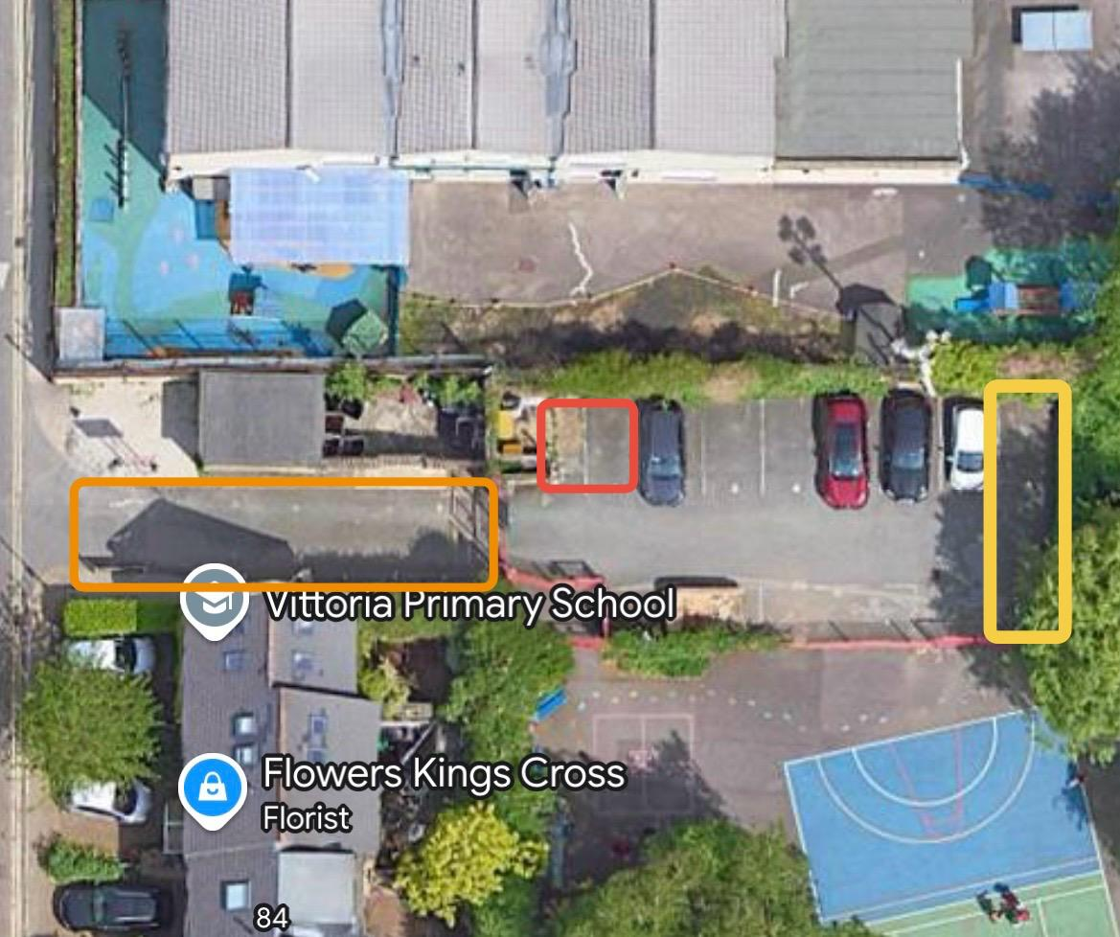

1.3. Key Considerations
This plan highlights the considerations trade contractors need to take when having goods delivered or collected from site; hence it will affect all trade contractors.
It is paramount that all site personnel and delivery drivers understand that the public and school children will be using the footpaths that cross the site entrance and that the procedures highlighted in this document shall adhered to for the safety of all concerned.
These considerations include:
- Risk Assessments
- Ensure control measurements are followed
- Continuous feedback to Axis for any necessary re-appraisal of this plan
- Choice of delivery vehicle
- Appropriate certification and training certificate available.

2. Health & Safety Legislation and Guidance
The key legislation and guidance in respect to traffic management and logistics includes:
Key Legislation
• Health and Safety at Work Act 1974
• Construction Design & Management Regulations 2015
• Provision and Use of Work Equipment Regulations 1998
• Lifting Operations and Lifting Equipment Regulations 1998
• Health & Safety (Safety Signs & Signals) Regulations 1996
• The New Roads and Street works Act 1991
• Management of Health & Safety at Work Regulations 1999
The Road Vehicles (Construction and Use) Regulations 1986
Key Guidance
• The Safe Use of Vehicles on Construction Sites [HS(G)144]
• Protecting the Public - Your next Move [HS(G)151]
• Workplace transport safety - [HS(G)136]
• Managing vehicle safety at the workplace – INDG 199

3. Key Aspects of the Plan
This Traffic Management Plan will be reviewed and updated periodically as on-site presence increases and/or layout changes.
Prior to any works commencing a site induction will be given where all relevant information shall be conveyed. This shall include information on the hazards associated with working in a live environment and the general provisions that shall be made for the protection of the public. The induction shall also include all relevant information relating to working close to the public highway.

  - Site security and signage
The site compound will be fully fenced in, and both entrance and exit will have a locked gate that must remained closed and padlocked at all times to prevent unauthorised entry from members of the public. Signage must be clearly displayed around the hoarding with Axis out of hours emergency contact number clearly displayed.

3.2 Site access and egress
All Axis employees, operatives and client representatives entering the site must enter from the school gates via Treaty street, go straight to the office and sign in. The exit from the site is the same as the entrance route.
All deliveries must be brought through the main school gates either manually (if in school hours) or if feasible with a delivery vehicle. All drivers should call the site manager prior to arrival to arrange access.

3.3 Restrictions

All trade contractors are to note the following restrictions within the site:

- Strict adherence to site rules issued by Axis Europe
- Smoking only in designated areas
- No children or animals allowed on site.
- Turn off all engines when in unloading/ loading position where possible to prevent excessive exhaust fumes.
- Axis Europe reserve right to refuse deliveries from drivers without correct certification for lifting machinery and operators’ certification.
- Parking restrictions in applicable
- Client restriction if applicable
- Road restriction if applicable
- Speed restrictions of 5mph
- Pre-booking of deliveries if applicable (call ten minutes before arrival)
- No parking or mounting of any pavement with delivery vehicles
- No reversing without a banksman in place
- Maximum of three Ton trucks allowed on site due narrow roads/bollards and 14 days notification needed to suspend parking bays
- No vehicle movements whilst children are in school, unless arranged and agreed by management.

3.4 The Separation of Pedestrians and Vehicles

The following measures have been taken to make both pedestrians and vehicles aware of each other around this site entrance.

    - No parking or mounting of external boundary kerb for purposes of waiting, goods loading or offloading.
    - Signage to warn pedestrians on the public footpath of a vehicle entrance.
    - Signage to warn delivery drivers of pedestrians crossing.
    - Physical demarcation barriers within the loading bay to protect site personnel from risk of being struck by site vehicles and to stop personnel from wandering into the loading bay.
    - Banksmen provided by Trade Contractors to ensure safe exit/ entrance.
    - Provision of a separate pedestrian access via pedestrian gate to school playground..
    - Trade Contractors to place small barriers to side of footpath to ensure pedestrians are aware of vehicle movement.

3.5 Vehicle and Plant Routes

On arriving at site, the driver must report to Axis Europe Site Office for induction.
It is the Trade Contractors responsibility to make the delivery drivers aware of the following points before they arrive on site.

- WRRR
- Awareness of current site layout and traffic direct
- Strict procedures for reversing
- Controlled by a suitably attired banksman
- Selection of the right type of vehicle for the site conditions
- Procedures of site safety and public protection
- Cleanliness standards of the public footpath and highway
- Limited turning circle
- Width / Height restrictions on site
- No waiting for vehicles on site
- Procedures for vehicle movement including loading/unloading and working from a vehicle

3.6 Control Measures for Reversing Operation (if required)

The following procedure is to be adopted when deliveries are reversing into the site.

- Place small barriers issued by Trade Contractor either side of footpath to ensure pedestrians are aware.
- Deploy Banksmen on pedestrian footpath so as to halt any pedestrians trying to cross while reversing is taking place.
- Drivers and Banksmen should be in constant communication during reversing.
- Banksmen should never stand directly behind reversing vehicles.
- Ensure that all reversing warning lights and alarms are in good working order.

3.7 Loading and Unloading

This project will have specific allocated loading/Unloading areas, so it is imperative that vehicle movements are kept to a minimum to avoid congestion. Refer to Appendix 1.

Loading and unloading needs to be done quickly and efficiently without compromising safety.

The delivery driver while on site is under the strict supervision of the Trade Contactor and Axis PIC. All delivery drivers are subject to site rules and are to ensure that the correct PPE is worn when out of the cab (Helmet, hi-vis jacket and steel toe-capped footwear, gloves, and glasses).

Procedures for all Deliveries to Vittoria school.

As detailed on the delivery sequences/vehicle movements above, a detailed delivery system will be in operation throughout the project. The key points of this system and the management of it will be:

a. Deliveries must be booked 48 hours in advance. This will allow Axis Europe to coordinate and prioritise vehicle movements during these final 2 days.

b. The traffic marshals/banksmen must be in place prior to delivery in readiness to receive the vehicle.

c. On arrival to site the lead traffic marshal shall check if the vehicle in question is:
• Booked
• Arriving at their pre-booked arrival time.
• Been inducted

Delivery site process:

- Park in the allocated loading bay in position directed by Axis PIC or Trade Contractor’s banksman
- Turn off engine
- Vehicle to have edge protection when unloading/loading
- Unload/ load materials safely under supervision
- No vehicle should be loaded beyond its safe working capacity, loads projecting out of the body of the vehicle should be indicated with a warning flag
- Appropriate equipment for unloading/ loading is required. It is the Trade Contractors responsibility to ensure that materials are moved to any allocated storage area or place of installation
- Drivers are to ensure that no rubbish is left behind, relevant Trade Contractors will be charged for the disposal of this if left
- Place barriers and signage issued by Axis Europe either side of footpath to ensure pedestrians are aware
- When finished carefully turn right out of site again following the one-way route, ensuring banksmen stop pedestrians crossing
- Trade Contractor to adhere to site Logistics Plan loading zones.

Note: Any damage caused by mounting the pavement with vehicles, will result in the making good of that damage being charged to the Trade Contractor causing the damage.

3.8 Storage

Procedure for Storage of Materials

- Trade Contractors are to ensure that they have sufficient means of unloading/ loading materials.
- No plant or labour will be supplied by the client to assist in offloading matter.
- After delivery it is the Trade Contractors responsibility to distribute materials to their place of storage or installation.
- There is no long-term storage of items in the loading bay. Deliveries must be distributed to storage areas on the appropriate level or place of installation as soon as practically possible after delivery.

NOTE: All materials will be unloaded/ loaded by Trade Contractors own operatives.

3.9 Public Protection for Vehicle Deliveries to Project (if required)

Trade contractors must place clear signs at both sides of pavement to indicate site entrance.
Trade contractors must place barriers either side of the footpath to denote vehicle movement

3.10 Procedures of working from a lorry

To prevent falls from height when working from a lorry:
- Avoid the need to work at height wherever possible, i.e. From the ground
- Where this cannot be avoided use measures such as platforms with barriers to prevent falls
- If there is a risk of a worker falling, use personal protective equipment to minimise both distance and consequence in the event of a fall

Trade contractors to always consider measures that protect everyone who is at risk before measures that only protect the individual. The walkways of the working platform should be made of non-slip material.

3.11 Information for Suppliers and Transporters

- All deliveries need to be logged in 48 hours beforehand
- Strict adherence to the delivery schedule and logistics Zones.
- Axis Europe will use discretion with all vehicles that arrive unannounced as to whether they are to be admitted to site.
- All drivers to carry Hiab Lifting Appliance Certificate and Operators Certificate.

3.12 Vehicle Selection

- Vehicles should be suitable for the purpose of which they are used
- Adequate visibility for driver
- Satisfactory warning devices (e.g. reversing alarm)
- Satisfactory standard of roadworthiness
- Drivers should be provided with a list of the daily checks to be signed off at the start of each shift. This should be monitored to ensure the checks are carried out properly.

Appropriate certification for Hiab and Operators certificate.

4. Key roles and responsibilities

The following key roles and responsibilities for the traffic plan are set out below:

Operational Manager/Contract Manager/ Axis Site Managers

- Assist with planning and preparation of project traffic management strategy, and updating where required
- Make specific reference to the strategy in the Project Construction Phase Plan
- Ensure a site-specific risk assessment is carried out for all traffic activities (arrival, departure, (un)loading, movement, maintenance etc).
- Ensure project induction is available to all pedestrians and drivers, which shows key routes, restrictions etc
- Monitoring and reviewing health and safety performance of all parties
- Ensure there are adequate emergency procedures in place for all foreseeable events i.e. traffic issues, spills, medical evacuation, fire
- Ensure there is adequate lighting on all access routes and common user areas

Duties of Traffic Control on Contractor

- Traffic management control
- Provide segregated pedestrian and vehicle routes
- Provision of materials and equipment to support the traffic management system/ strategy
- Provision of competent resources
- Assist Axis Europe management in the production of ‘Traffic Management Plan’
- Effective implementation of Traffic Management Strategy
- Performance measurement and to personnel involved in controlling feedback to Axis Europe management regarding traffic management strategy and contractor compliance
- Liaison with Axis Europe construction management
- Carry out Risk Assessment in respect of traffic management
- Facilitate deliveries and management of delivery / logistics strategy

Trade Contractors
- Comply with traffic management strategy
- Report issues with strategy
- Ensure all personnel attend project induction
- Provide competent workforce and supervision
- Investigate any accidents / incidents and ensure necessary control measures are put in place and communicated to the Principal Contractor
- Provide plant / equipment which complies with relevant statutory obligations

Drivers / plant operators should be competent and trained to the appropriate standard, drive with care and comply with the requirement of project strategy, use the correct equipment for the task, ensuring they are suitable for use, marked with safe working load, properly maintained, inspected, and thoroughly examined regularly.

Resources
Key Personnel
Contracts Manager: | Robert Walker
Site Manager: | Tom Ratcliff
Regional SHEQ: | Bianca Morutan
Banksman: | TBC
Vehicles & Plant |  | Labour | Materials
Skip Wagon  Delivery Vehicles |  | Site Manager  Tradesmen & Operatives – up to 10 | Building Materials
A copy is to be displayed on the H&S Notice Board

Risk Register
Process/Element | Associated Risk | Risk Rating | Control Measure | Residual Risk Rating | Reference Health & Safety Standards
Public using footpath | - Struck by delivery vehicle | - L-M | - Banksmen to stop public crossing while reversing into site. Clear Signage | - L | - HASAWA  - CON(HSW)  - The Safe Use of Vehicles on Construction Sites [HS(G)114]  - Protecting the Public - Your next Move [HS(G)151]
Banking vehicle into loading bay | - Struck by vehicle  - Trapped or crushed by vehicle | - L-M | - Banksmen to wear hi-visibility jackets.  - Maintain communication with driver at all times  - Never stand directly behind vehicle  - Ensure all vehicle reversing lights and alarms are working | - L | - HASAWA  - CON(HSW)  - The Safe Use of Vehicles on Construction Sites [HS(G)114]
Unloading vehicle | - Struck by falling objects  - Collapse of load  - Trapping/ cutting of fingers  - Injury through lifting | - M | - Loads to be properly stacked and secured. Ensure load is stable before untying  - Ensure use of gloves and PPE  - Use of mechanical equipment | - L | - HASAWA  - LOLER  - MHOR  - CON(HSW)  - PPE
Collision on exit of loading area | - Injury to driver and third party (in vehicle or on foot) | - L | - Signage  - Banksmen to guide vehicle out  - One Way traffic only | - L | - HASAWA  - The Safe Use of Vehicles on Construction Sites [HS(G)114]  - Protecting the Public - Your next Move [HS(G)151]
Vehicle movement in loading area | - Site Operatives struck by vehicle | - M-L | - No unauthorised pedestrian traffic in loading bay  - Use of PPE including high visibility jacket  - Barrier to segregate area. | - L | - The Safe Use of Vehicles on Construction Sites [HS(G)114]  - HASAWA

Appendix 1

Appendix 3 – Delivery Driver Site rules

Site Rules for Delivery Drivers

These Site Rules are to be given to all delivery vehicle drivers upon entering the site. When entering the site, it will be deemed that the driver has understood and will comply with the rules as set out below. Non-compliance with these rules will result in the person being asked to leave site.

- All deliveries to be booked in at least 48 hours in advance. There is to be no exceptions to this and if vehicles arrive that have not been booked in will be turned away without unloading.

- All vehicles must arrive on time for their delivery slot. Late vehicles will not be allowed access.

- Vehicles over-running their delivery slot and impacting on later deliveries will be asked to leave site.

- Vehicles which do not comply with the WRRR checklist will be turned away from site.

- DO NOT access the construction site until you have been briefed by the Traffic Operative – all vehicle movements onto the site must be under control of a trained and competent banksman.

- No vehicle is to unload out in the main public carriageway. Materials unloaded in this manner will be refused access onto the site.

- Vehicle drivers are required to remain with their vehicle at all times unless there is a form of contact left for the unloading team, i.e., radio, mobile telephone number, etc. If going through the site as a visitor, delivery drivers must be escorted at all times.

- All delivery vehicles to have sufficient edge protection if access onto the back of the vehicle is required.

- DO ENSURE that you wear your Visitors security pass at all times whilst on site.

- DO ENSURE that you wear a hard hat, protective footwear, and high visibility vest at all times on site (and when leaving your vehicle).

- DO ENSURE that you observe all H & S signs and notices displayed, (speed limit, walkways, etc.).

- DO NOT consume food or drink on the site, unless it is within the welfare facilities provided.

- DO NOT attend site under the influence of alcohol or drugs.

- DO NOT smoke on site except within authorised areas.

- DO NOT remove any guard-rail or cover to any hole unless you have been given express permission from your supervisor. Ensure protection measures are replaced on completion of your work activities.

- DO NOT undertake any work unless you have been briefed on the key aspects of the safe system of work by Subcontractor you are delivering for.

- DO NOT use faulty equipment.

- DO NOT manoeuvre / reverse unless told to do so. You will be given a designated holding area. Ensure Reversing Audible Alarm is working as well as your flashing beacon.

- DO NOT leave site until you have been cleared to do so by the Traffic Operative.

- If at any time you breakdown, liaise with Site Management Team or your Supervisor immediately.

- If the vehicle has a hiab or tail lift fitted all certification of training and respective tests of hiab / tail lift and sling / chains etc. must be issued to the Traffic Manager – BEFORE UNLOADING.

- Any materials delivered to site must be for inclusion within the works within the following three days. Any bulk deliveries which require long term storage will be turned away from site

FULL NAME (CAPITAL LETTERS) | SIGNATURE | COMPANY NAME | DATE

