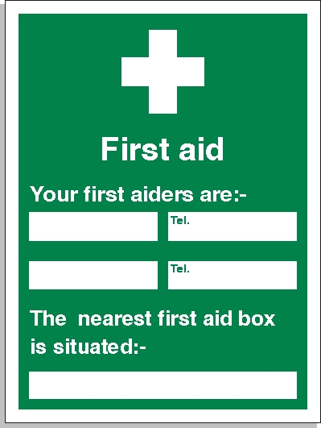

Calum Eyre
Eduard Birau
07886370198
07875221349
On each void

