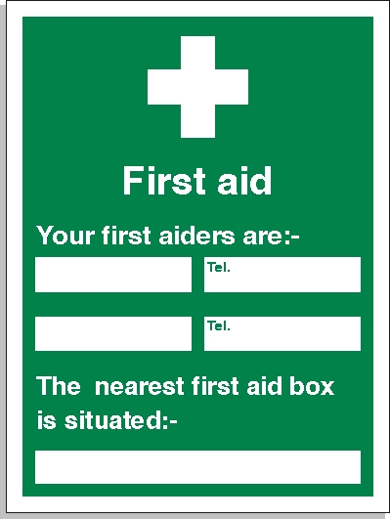

Alina Souca
Christine Lane
07940465613
07522 489326
Site Office - 38 Fryierning Lane, CM4 0DH

