
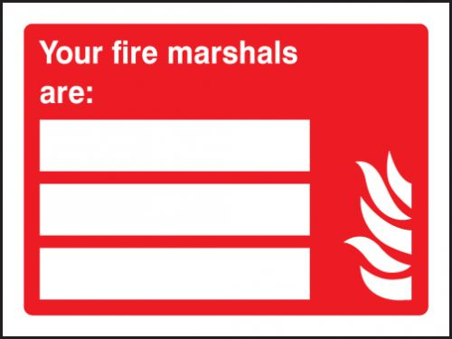

STEVE HARPLEY
07413839457
LUKE TOMLINSON
07426246657

