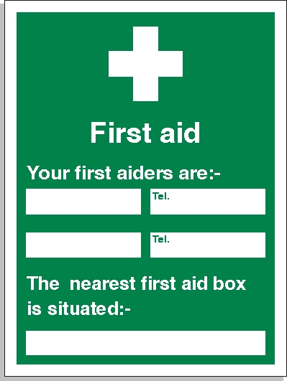

LUKE TOMLINSON
STEVE HARPLEY
07426246657
07413839457
Site Office

