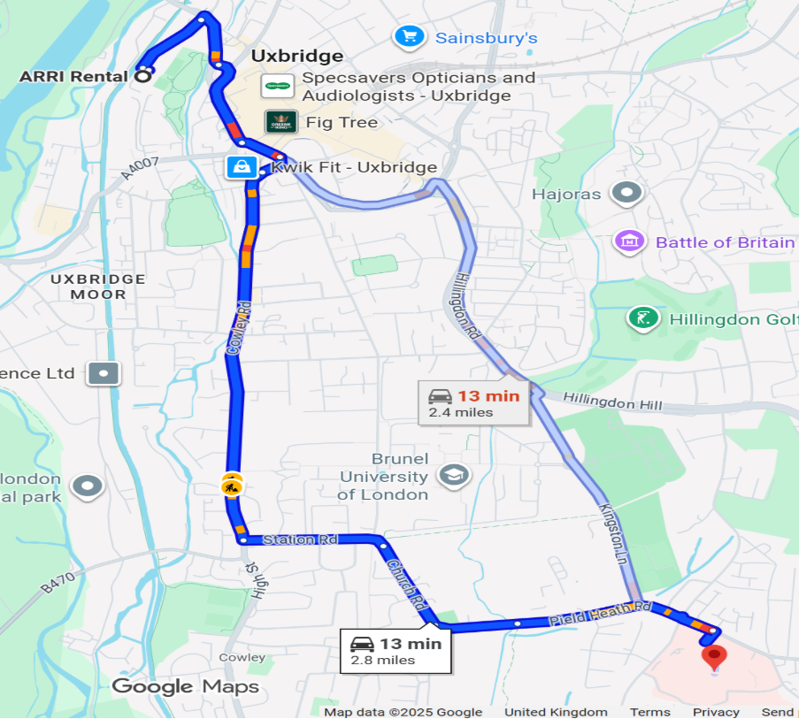
Nearest Hospital
ARRI rentals
Hillingdon Hospital,
Pield Heath Road
Uxbridge
Middlesex
UB8 3NN



