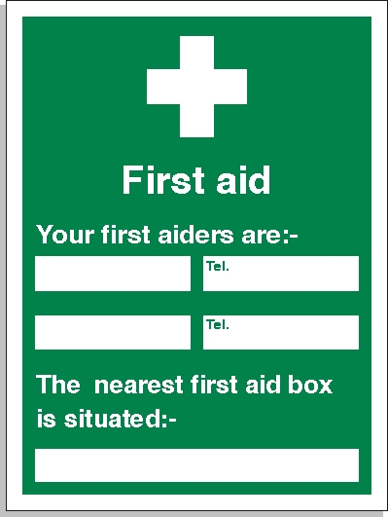
Site Office
07426246657
07413839457
Luke Unsworth
Steve Harpley

