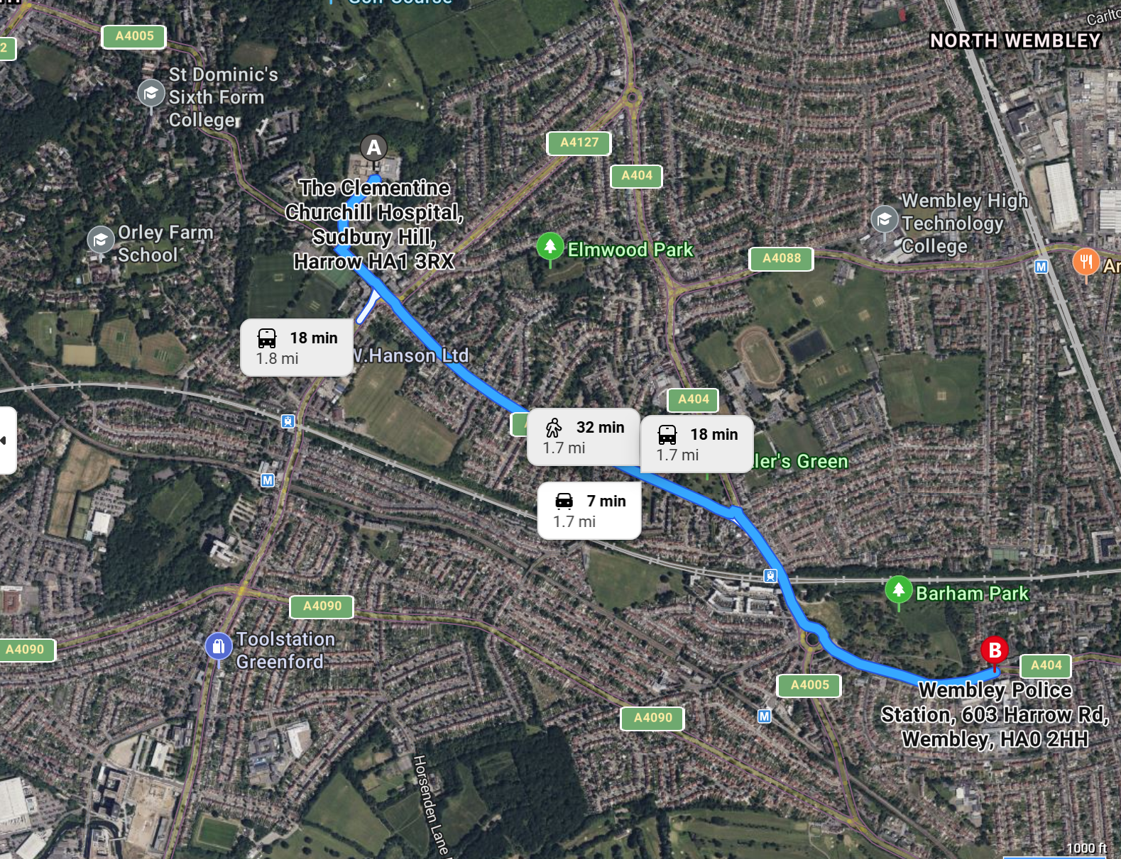
Nearest Hospital
Wembley Police Station

Nearest Hospital

Clementine Churchill Hospital
Sudbury Hill
Harrow
HA1 3RX

