

Construction Phase Health and Safety Plan

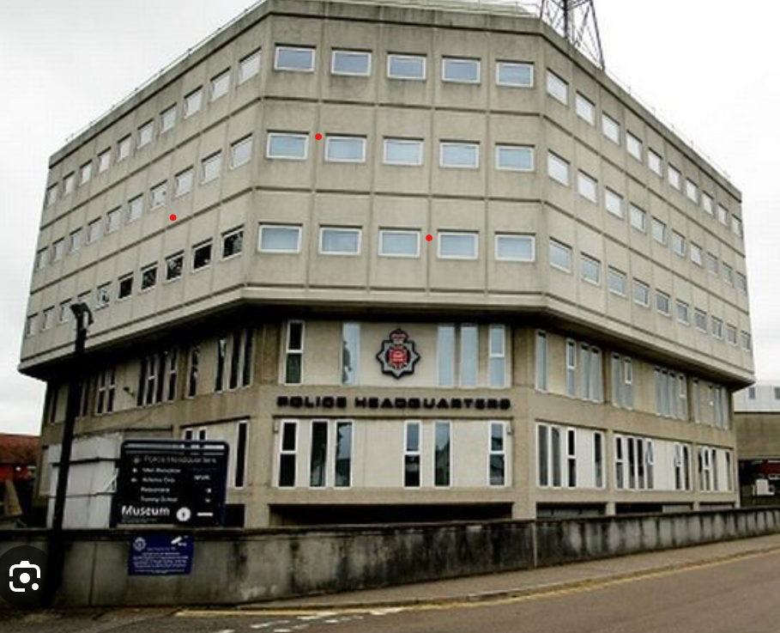

Essex Police HQ, PO Box 2, Springfield, Chelmsford CM2 6DA

DOCUMENT CONTROL SHEET
Version 1.0
Prepared by | Checked by | Checked by | Checked by
Name: Nici Moran  Job title: Project Administrator  Date: 17.07.26 | Name:  Job title:  Date: | Name:  Job title:  Date: | Name:  Job title:  Date:

Version 2.0
Prepared by | Checked by | Checked by | Checked by
Name:  Job title:  Date: | Name:  Job title:  Date: | Name:  Job title:  Date: | Name:  Job title:  Date:

Version 3.0
Prepared by | Checked by | Checked by | Checked by
Name:  Job title:  Date: | Name:  Job title:  Date: | Name:  Job title:  Date: | Name:  Job title:  Date:

Content
Document control sheet
Description of project
Summary project information
Details of key personnel
Management structure
Health & Safety Arrangements
Monitoring and reviewing health and safety performance
Active Monitoring by the PIC
Reactive Monitoring
Project reviews
Arrangements to give direction and co-ordinate the contractors
Regular liaison between parties on site
Handling design changes during the project
The selection and control of contractors
Display of statutory notices
Training
Emergency procedures
First aid
Accidents, incidents and near misses
Fire safety
Site security
Welfare facility
Risk assessment and method statement
Site rules
Axis Europe site rules
Client rules
Permit to work
Axis Europe arrangements
Client requirements
Risk register
Site Waste Management Plan
Health & safety (O&M Manual)
Appendix 1: CDM 2015 roles and responsibilities

1 Description of the project

1.1 Summary Project information
Project Name | Installation of Forensic Freezers
Project Number | To Follow
Project Address
Description Scope of works | Installation of 2no forensic freezers and associated works
Information provided | - Existing and proposed construction drawings  - Specifications (landscaping, structural, civils, electrical)  - Pre-construction Information and reports  - Schedule of works
Contract period | 6 weeks
Anticipated date for possession
Anticipated date for completion
Existing environment
Surrounding area | The surrounding area is made up of residential properties
Existing services | All buildings are served by existing services within the site boundary which comprises of: gas, electrical and water supplies.
Existing traffic system | .
Traffic Management | All deliveries are to be made to the car park on Hilldrop Road. The deliveries will then be transported into the work areas. The work area is mostly segregated by existing fencing, hoarding will be installed to any areas that are not.
Welfare arrangements | Use of existing welfare facilities in M Block as agreed with client. These facilities are shared by others whilst works are being undertaken. No parking on site

1.2 Details of Key Personnel

Project Client
Name | Alice Lodge
Address | Islington Council, Homes & Neighbourhoods, 222 Upper St, N1 1XR
Contact details | 07714 170258
E-mail | Alice.lodge@islington.gov.uk
Principal Designer
Name | Lucie Vosicka
Address | Islington Council, Homes & Neighbourhoods, Room G17, Town Hall, Upper Street, London N1 2UD
Contact details
E-mail
Project Lead / Contract Administrator
Name | Lucie Vosicka
Address | As Above
Contact details
E-mail
Principal Contractor
Name | Axis Europe
Address | Tramway House, 3 Tramway Avenue, Stratford E15 4PN
Contact detail | Simon Mantle
E-mail | Simon.Mantle@axiseurope.com

Subcontractor | Works Package | Address | Contact Name
First Choice Ltd | All Works | Unit 4 Kingston Farm, Downhall Road, Essex CM17 0RB | Steve Patten

1.3 Management structure

Role / Designation: | Team Member: | Notation: | Organisation:
Contract Administrator | Lucie Vosicka | CA | Islington Council
Principal Designer | Lucie Vosicka | PD | Islington Council
Safety Manager | Harley Baker | (SM) | Axis Europe
Person-in-Charge | TBC | (PIC) | Axis Europe
Site Manager | TBC | SM | Axis Europe

2 Health and Safety Arrangements

The organisation’s goal is to, so far as it is reasonably practical, provide a place of work that is safe and without risk to the health, safety and welfare of client staff, all employees, agency workers, contractors, members of associated companies, visitors and the general public and in so doing see that the project works are completed without incident.
Contractors are required to ensure they have competent supervisory personnel on site for the duration of the works and that all operations are subject to regular inspection and monitoring.
Neglect of health and safety provision will be considered as a serious disciplinary matter and will be dealt with accordingly. The PIC will stop any operation or activity if the works do not comply with the requirements of the method statement or if he / she considers there to be an unacceptable risk arising from unsafe practices. All contractors must ensure they have a written disciplinary procedure that is brought to the attention of those personnel under their control.

2.1 Monitoring and reviewing health and safety performance

2.1.1 Active monitoring by the PIC

Active monitoring is the responsible person going out and checking workplace conditions, practices, control systems, etc. for themselves so as to detect anomalies, etc. that have not been reported. The PIC & Safety Manager will be responsible for ensuring that statutory obligations are met.
- Weekly inspections: The PIC will conduct weekly inspections of the site or workplace.
- Statutory inspections: The PIC or authorised & competent person will conduct statutory inspections of scaffolding
- Site inspections: The Safety Manager will conduct inspections of the site, issuing reports where appropriate.

2.1.2 Reactive monitoring

Reactive Monitoring is the process of investigation into things that have gone wrong (such as accident investigation) and involves learning from mistakes. These mistakes may have resulted in injuries and illness, property damage or near misses.
The Safety Manager with the aid of the site team will be responsible for ensuring that statutory obligations are met by investigating:
- Injuries and causes of ill health.
- Other losses, including damage to property and equipment.
- Incidents, including those with the potential to cause injury, ill health or loss.
- Dealing with hazards, including weaknesses or omissions in operating systems.

All inspections are completed electronically and the results are available to the business via Microsoft Business intelligence software. A monthly report is given to the chief executive and directors showing the overall findings across the company. The results for specific site inspections will be discussed with the person in charge who will take any appropriate action with the persons responsible for performance that is either
- Better than expected
- Less than expected.

Results of monitoring will also be discussed at project meetings so that themes can be identified which can be dealt with initiatives such as
- Tool box talks
- Safety briefings
- Disciplinary action
- Reward and recognition actions

2.1.3 Project reviews

Throughout the Project and upon completion, the Senior Projects Manager or Contracts Manager will conduct a formal review of all aspects of the project.

2.2 Arrangements to give directions and to co-ordinate the contractors

Regular liaison between parties on site

- Axis Site Manager will engage each morning with site security and building management to discuss their planned activities for that day including any deliveries, collections, waste removal or any H& S concerns. They will then agree a mutually beneficial way of working safely around each other.
- The PIC will liaise with the Client where required on a regular or ad hoc basis.
- The SPM / Contracts Manager and PIC will encourage all members of the project team, including contractors and their personnel, to offer advice on health and safety particularly where the planned work of one contractor has the potential to impact or have an adverse effect upon another.
- The PIC will communicate with the workforce periodically by: regular consultation meetings, induction for all new starters, daily briefings where required and a programme of appropriate toolbox talks.

2.2.2 Handling design changes during the project

Significant design changes by contractors: All Changes must be notified to the Contracts Manager and agreed with the Principal Designer and Contract Administrator. The contractors must also carry out a risk assessment and give due consideration to avoiding, minimising or controlling the risks. Copies of new risk assessments and safety method statements are to be supplied to the PIC for inclusion on the Project Safety File.
Unforeseen, non-designer generated changes: All such changes are to be evaluated by the Contracts Manager and the contractors, reference shall be made to the Safety Manager if necessary.
Design coordination and communication of design changes must be carried out through design team meetings and recorded in minutes. The design team meetings will include Axis, the Client, Principal Designer and Axis’ specialist subcontractors. Axis will maintain an RFI schedule relating to any design changes that will be shared with the forementioned parties via email.
Where applicable, any requirement for Temporary Works will be planned and co-ordinated by the TWC in line with BS5975.
The Temporary Works Coordinator (TWC) is appointed to manage any temporary works on site. A temporary works risk register detailing the temporary works items will be maintained on site with any design drawings and calculations and regular recorded inspections of any temporary works items permanently erected e.g. heras fencing, trench support systems should be carried out.
In line with CDM2015, a design risk review will be undertaken at regular intervals to ensure coordination between the designers involved in the project giving cognisance to the requirements of the school for future cleaning and maintenance requirements.
Details of design considerations and mitigation/or close out of hazards will be formally recorded. Residual hazards must be recorded and provided to the Principal Designer for inclusion within the Health and Safety File.

2.2.3 The selection and control of contractors

The Contracts Manager will ensure, via the standard procedures of the company, that contractors engaged on this project are competent to carry out their specific works and that they have made adequate provision for health and safety.
All contractors complete a prequalification process and have to provide
- SSIP accreditation (CHAS, SafeContractor,ConstructionLine)
- Gas Safe (if applicable)
- NICEIC (if applicable)
- NASC (if applicable)
- Asbestos Licence (if applicable)
- RAMs for activities
- H&S competent person qualifications (if applicable)
- Accident/Incident statistics
The SPM / Contracts Manager will liaise with the Safety Manager; they will be responsible for monitoring the appointment and on-going performance of contractors and suppliers employed on this project.
Records of plant and equipment maintenance will be inspected before use on site
All PAYE operatives will complete the Axis Passport to Work Scheme (appendix 4)
All sub contractors will require suitable training certificates
- CSCS test
- Gas Safe card (dependent on role)
- CISRS card (dependent on role)
- Asbestos awareness
- PASMA (dependent on role)
- IPAF (dependent on role)
- SMSTS (dependent on role)
- SSSTS (dependent on role)
Further sub-contracting without the express and written consent of the SPM / Contracts Manager will be forbidden.

2.2.4 Display of Statutory Notices

Statutory notices will be displayed as follows:
- H&S Law Poster
- Axis Europe insurance certificate
- H&S Policy statement

We shall also display the following information in the form of an information board / sign –
- Local Authority with name who has given the authority.
- Name of Client.
- Name of Principal Contractor and contact details of site Manager.
- Emergency 24 hr contact number.
- Site Progress Info Board

2.2.5 Training

- Site induction- the SM will deliver an induction to all visitors and site personnel, including new starters and those of contractors. Registers will be kept in the Project Safety File and attendance will be a pre-condition of gaining access to the working areas.
- Toolbox talks and onsite training: The PIC has access to a comprehensive range of toolbox talks which will be delivered as required to company personnel, and others if necessary. The Company requires that all contractors operate their own programme of talks for personnel under their own control for the duration of the works; they must maintain detailed records of talks, which are to include the names of the attendees and the date of delivery. Copies of records are to be provided to the PIC and copied to the Project Safety File, the arrangements of contractors will be monitored by the PIC
- Records of health & safety training: Records of training (and competencies) are to be made available to the PIC and copied to the Project Safety File.

2.3 Emergency procedures

2.3.1 First Aid
- Contractors: All contractors are required to provide an adequate number of personnel suitably trained in first aid. Contractors are to submit the names of qualified personnel to PIC who will inform the workforce by posting notices of the first aid arrangements made within the offices and canteen / rest area.
- Axis Europe arrangements: The PIC is trained in first aid and will act as the focal / contact point for provision on site. If the PIC is absent, Axis will arrange suitable cover from a competent first aid trained site manager to oversee this role.
- First Aid kits / equipment: All contractors are required to provide fully equipped first aid kits within their working areas and arrange for the replenishment of consumable items as required.
- Contacting the emergency services: The PIC will contact the emergency services if required.

2.3.2 Accidents, incidents and near misses

- All personnel (including those of contractors) are required to report any injury to the PIC who will make an entry into the project accident book and implement the company accident procedure. Copies of all accident book entries and reports will be held securely at head office by the Safety Manager who is the designated appointed person. Where appropriate copies will be made available upon request to the Principal Designer or the appointed person(s) of contractors.
- Accidents, incidents and dangerous occurrences are to be reported to the Safety Manager within an hour of finding out about it. Those of a fatal or serious nature are to be notified immediately; they must then be followed up with completed report form(s) within the prescribed period in accordance with RIDDOR.
- Investigation of accidents, incidents and near misses: Details of all accidents, no matter how trivial, must be entered in the project accident book. All personnel (including those of contractors) are required to co-operate with the Safety Manager who is to be provided with copies of the results of any investigations carried out by contractors.
- Investigation by the PIC: The PIC will complete an initial investigation.
- Investigation by the Safety Manager: Depending on the nature of the accident, the Safety Manager will carry out an investigation subsequent to that conducted by the PIC where required.
- Any RIDDOR Reportable incident should also be Notified to the Client
- Accident/Incident Reporting & Investigation - All accidents, incidents and near misses need to be reported to the client contract administrator and PD, and where an investigation is required a copy of the report will need to be provided

2.3.3 Fire Safety

- A fire safety plan will be drafted; the workforce and personnel under the control of contractors will be briefed in respect of the plan and a copy will be displayed.
- All corridors, emergency routes and exits remain unimpeded by debris, materials and plant or equipment for the duration of the works. These routes will be regularly inspected, and defaulters will be required to remove any offending article to the working area or secured storage, or they will be required to dispose of it off site with immediate effect.
- General awareness: Notwithstanding the briefing and induction by the PIC, it remains the responsibility of contractors to ensure that personnel under their control remain fully aware of the location and correct use of the following:
  - Fire extinguishing equipment
  - Emergency evacuation procedures
  - Escape routes and fire exits
  - Assembly points
- Flammable materials: Contractors must ensure that the quantity of flammable materials within the working area(s) is kept to a minimum. All such materials are to be carried and stored in suitable close containers and in ventilated areas if required.
- Smoking: No smoking on site
- Checks: PIC and Contractors must ensure that they check the working areas at lunch / break times and at the end of the working shift / day to ensure that all plant and equipment that could cause a fire is turned off and made safe.
- Rubbish and waste: PIC and Contractors must ensure that rubbish and waste is bagged and regularly removed from the working areas. Flammable waste must be stored separately in closed fire resisting containers and removed in a similar manner.
- Notifying the emergency services: In the event of an incident contractors must notify the PIC who will be responsible for calling the appropriate emergency services.
- Access for emergency services: PIC and Contractors must ensure that there is adequate access to the working areas at all times.
- Guidance and direction of emergency services: In the event of an incident contractors must ensure that competent member of their workforce is available to assist the PIC in directing the emergency services.
- Fire emergency arrangements – The appended (Appendix 3) Fire Action Plan, details all Fire alarm call points. In the event of a fire, Axis management staff, and all operatives are briefed on raising the fire alarm and then following the fire evacuation strategy.
- Site Fire Warden – The PIC/Site Manager is the appointed site fire warden.
- Site Fire Plan – The site fire evacuation plan (Appendix 4) details the identifying fire escape routes / exits from external work areas, muster point and fire point locations.
- Coordinating the site fire arrangements with the school – Axis site fire plan to be shared with the School stakeholders.
- Any person discovering a fire -
- Sound the alarm (see fire action plan/appendix 3 for details of fire alarm call points)
- Exit the site via the fire escape route (see fire evacuation plan)
- Report to the muster point

2.3.4 Fire Risk Assessment

Hazard | Risk | Controls
Smoking on site | Cigarette may ignite flammable materials | Smoking cigarette’s on site is strictly prohibited. Operatives must leave the site if they intend to smoke.
Flammable substances | Accidental fire or explosion | No storage of flammable substances is allowed on site. COSHH assessment undertaken and appropriate controls implemented and monitored by site management
Combustible materials | Accidental fire | Reduce storage of combustible materials by limiting the time they are stored on site through JIT ordering. Any combustible materials must be stored away from ignition sources, heat, and escape routes in a well-ventilated area.
Hot works | Accidental fire or explosion | A hot permit to work must be in place before hot works commence following all safe systems of work. Finish hot works 2 hours before end of shift. Area to be inspected prior to any work and exclusion zone and signage to be in place to keep away and warn unauthorised operatives. The area will be swept of loose debris and materials or combustible materials adjacent to the working area will be removed. Fire extinguishers to be strategically placed into the hot work area. Extinguishers to be in date and equipment to be inspected before use.
Storage of waste/rubbish | Accidental fire | Avoid rubbish to be built up and arrange its removal regularly.
Faulty Electrical equipment | Accidental fire or explosion | All electrical equipment must be PAT Tested. Any items that are not PAT tested are prohibited on site. All equipment must be inspected daily for any signs of faults prior to use.
Faulty plant | Accidental fire or explosion | All plant should inspected upon delivery and daily before operation. Plant should only be stored on site for the minimum time it is required for. Should be off hired and removed from site promptly following completion of task requiring its use. Work area should be cleared of any combustible materials prior to use and an exclusion zone set up. Fire extinguishers to be present in proximity.

In the event of a fire:
- Sound the alarm (see fire action plan/appendix 3 for details of fire alarm call points) if you are in close proximity to a fire alarm call point
- Exit the site via the fire escape route (see fire evacuation plan)
- Report to the muster point
- Do not return to the site for any reason until the PIC has given authorisation to do so
- PIC to alert the School Building Manager

Beacon High School - Local Emergency Services

Emergency Services: | Contact details
Fire | 999
Ambulance | 999
Police | 999
Hospital | Whittington Hospital, Magdala Ave, London N19 5NF
Defibrillator

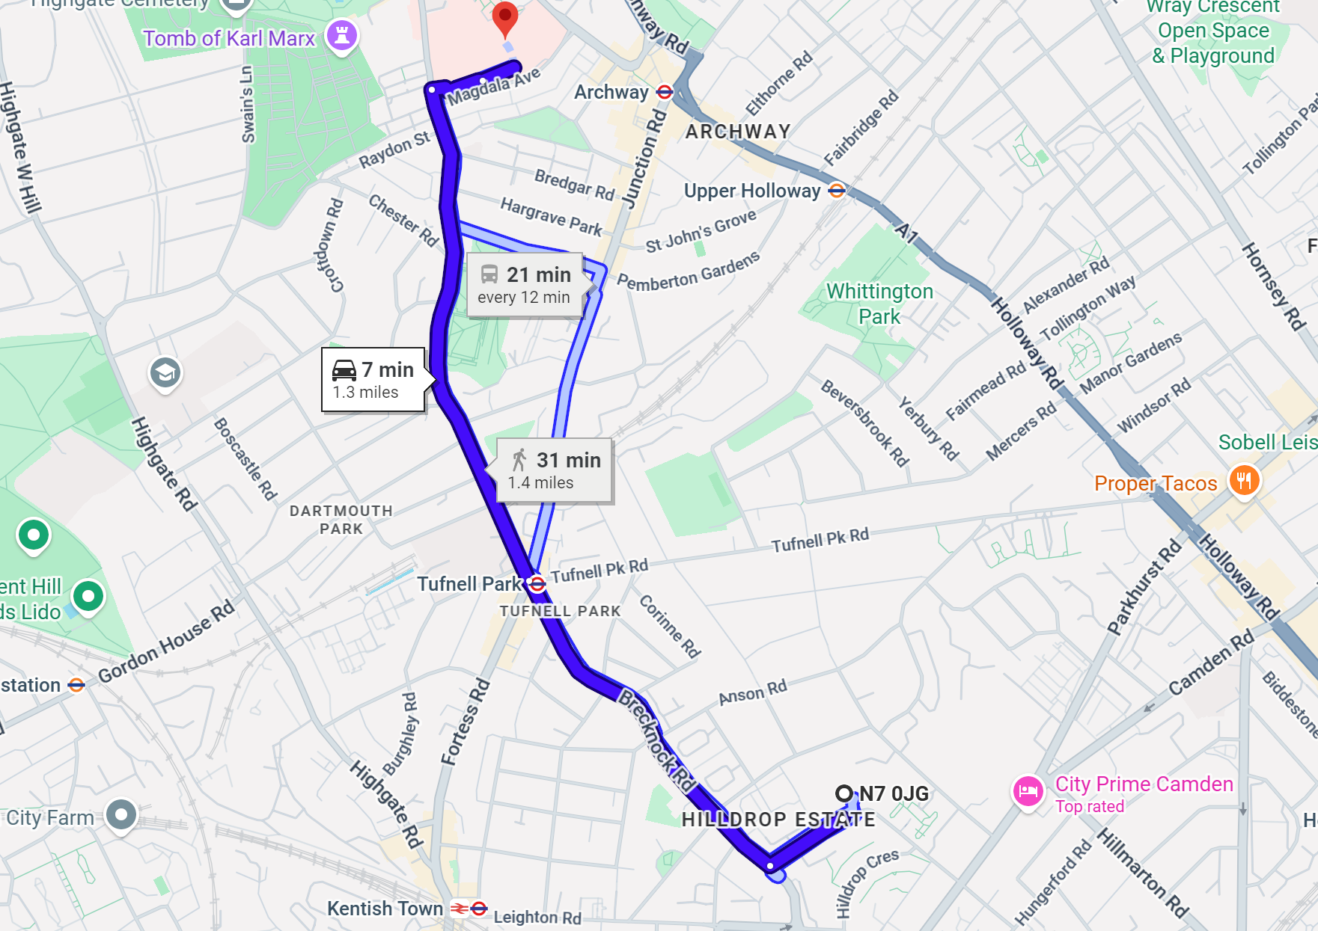

2.4 Site Security

Security on the project will be maintained by ensuring that only authorised persons are allowed onto site / into the working area(s). The following procedures will be implemented:
- Contractor’s personnel will be required to wear approved ID tags and corporate clothing. The PIC will carry out regular checks to ensure compliance.
- All personnel and visitors will be required to report to the PIC and indicate their presence by signing in at the site offices on arrival and signing out when leaving. The PIC will keep a register for this purpose.
- Visitors will be briefed with regard to any hazards or special requirements. The relevant PPE will, if they do not have their own, be provided and they will be accompanied whilst within the working area(s).
- The PIC will ensure that the working area(s) are clear of all personnel and secured before leaving at the end of each working day and / or shift.
- Persons without the appropriate authority / identification will, in the interests of their own safety, be refused entry to the working area(s) by the PIC.
- Axis will install heras fencing, hoarding and permanent fencing as per the site layout plan, to securely segregate all designated site areas at all times and will include warning signage on display. All access points will be secured via padlock and all access and egress to the site will be co-ordinated by the PIC/Site Manager.

2.5 Welfare Facility

Welfare facilities will be available to the workforce at the start and for the duration of the works, located within the site
- Sanitary conveniences
- Washing facilities
- Drinking water
- Seating area

2.6 Risk Assessment & Method Statement

- Identification of hazards: The Contracts Manager and PIC have conducted an overall assessment of hazards in respect of the project and those hazards identified by the client’s advisors / design team have also been identified within Section 3 of this Plan
- Production of risk assessments by contractors: All contractors are required to assess the risks associated with their activities, carrying out both general and specific assessments where necessary. Risk assessments are to be signed-off by the contractor’s Safety Manager/competent person prior to being forwarded to the PIC. Personnel under the control of contractors must be briefed, with records of briefings maintained. Copies of risk assessments and briefing records are to be forwarded to the PIC and copied to the Project Safety File.
- Production of risk assessments by the Company: The PIC, with the assistance of the Safety Manager where required, will assess the risks associated with those activities or tasks to be carried out by the company workforce, carrying out both general and specific assessments where necessary. Risk assessments will be signed-off by the PIC, the workforce briefed and copied to the Project Safety File.
- Approval of risk assessments: All contractors (and their sub-contractors) are to comply with the project specific procedures
- Production of method statements by contractors: All contractors, having assessed the risks associated with their activities, are required to produce comprehensive method statements for safe working identifying the relevant precautionary measures required to ensure their activities are carried out without risk. Method Statements are to be signed-off by the contractor’s Safety Manager/competent person prior to being forwarded to the PIC. The personnel under the control of contractors must be briefed in respect of each method statement. All work must be executed in accordance with the method statements. Records of briefings are to be maintained. Copies of method statements and briefing records are to be forwarded to the PIC and copied to the Project Safety File.
- Production of method statements by the Company: The PIC, with the assistance of the Safety Manager where required, will produce comprehensive method statements for safe working identifying the relevant precautionary measures required to ensure those activities or tasks carried out by the company workforce are done so with the minimum practicable risk. Method Statements will be signed-off by the PIC, the workforce briefed and copied to the Project Safety File. All work must be executed in accordance with the method statements.
- Review of method statements: All contractors (and their sub-contractors) are to comply with the project specific procedure. A method statement status form will be completed by the PIC.
- Timescale for Review of method statements: contractors are to note that they are required to submit all risk assessments and method statements to the PIC for review at least 5 working days before their works are due to commence.

2.7 Site Rules

2.7.1 Axis Europe Site Rules
- Site Safety Rules: Have been identified and will be implemented for the duration of this project, personnel will receive be briefed upon requirements at the induction delivered by the PIC and a copy will be displayed. Site rules which will be displayed on site are in Appendix 2.
- Conditions of appointment: contractors must comply with the requirements of their appointment. Any area of conflict between this Health and Safety Plan and the conditions of appointment must be brought to the attention of the SPM / Contracts Manager.
- No drugs or alcohol shall be allowed on the site, or any person who is considered to be under the influence of drugs or alcohol
- Smoking is not permitted on site
- The PIC/Site Manager shall hold an DBS and will be responsible for escorting all operatives while on site. All Supervisors/operatives must hold a DBS and a list of operative names and certificate numbers be provided to the School Site Manager. Axis is currently waiting receipt of the Site Managers enhanced DBS. CPP to be updated once received.
- The use of mobile phones and taking photographs is strictly prohibited outside the confines of the site.
- Interactions with Students is to be avoided wherever possible.
- Operatives must stay within the confines of the site at all times.
- No plant, equipment or tools are to be left unattended at any time and at the end of shift must be secured in the site compound, dismantled, locked away or removed from site.
- All excessively noisy and dusty works should be planned and coordinated with the school to mitigate the impact on the school occupants. Where required environmental noise monitoring should be implemented
- Operatives must only access areas that have been authorised and agreed with the school
- Radios, cassette players, personal stereos or similar are prohibited
- Any person using abusive language, wolf whistling or similar will be expected to be removed by the Principal Contractor from the site
- No fires on site; the Principal Contractor must comply with the Joint Code of Practice Fire Prevention on Construction Sites, 7th Edition
- Lone working on site is not permitted
- All site operatives and personnel, including visitors, shall be aware of the evacuation procedures in the case of an emergency
- All escape routes must be kept clear of plant, tools, materials and rubbish at all times
- All fire exit doors to be maintained at all times and must be left unobstructed
- Hours when the contractor is permitted to work must be strictly adhered to

2.8 Permit to work

2.8.1 Axis Europe arrangements
- Overview: if justified by the risk assessment of the activity, the PIC will operate a permit to work system which is a formally documented procedure designed to provide additional safeguards for specified activities, places or environments e.g. Hot Works, Work in Confined Spaces or HV Electrical Work etc. The permit system is a strictly controlled and systematic safety procedure providing a clear written record that foreseeable hazards have been addressed and adequate control measures implemented.
- Requirements of a permit to work system: The system must include / ensure the following:
  - Only an authorized person will issue the permit.
  - All personnel involved in the activity UNDERSTAND the hazards and precautionary measures that are required; this means an effective briefing is to be given to the workforce in respect of the activity and any associated hazards and control measures.
  - The area, place, environment or activity affected by the permit must be clearly defined.
  - The period of time for which the permit is approved must be clearly defined.
  - The correct personal protective equipment (PPE/RPE) must be clearly defined, provided and used by the workforce.
  - The permit is to be accepted by a suitably competent person-in-charge.
  - Completed or when the time limit for the permit has expired. Incomplete works will require the issue of a new permit.
- Available permits: The following permit templates are available from the PIC for use on this project:
  - Confined spaces
  - Electrical
  - General
  - Hot works
- All contractors must ensure that personnel under their control are provided with all appropriate information, instruction and supervision to ensure the effective implementation of project specific requirements.
- The issuing of any permit to work is entirely dependent upon the provision of the following supporting documentation:
  - Method Statement Review Sign-off (completed by the PIC)
  - Risk Assessments (provided by contractors & signed-off by their competent persons/Safety Managers).
  - Method Statement (provided by contractors & signed-off by their competent persons/Safety Managers).
  - Permits will be issued on a daily basis, being issued at the beginning and cancelled at the end of each day/shift by the PIC.

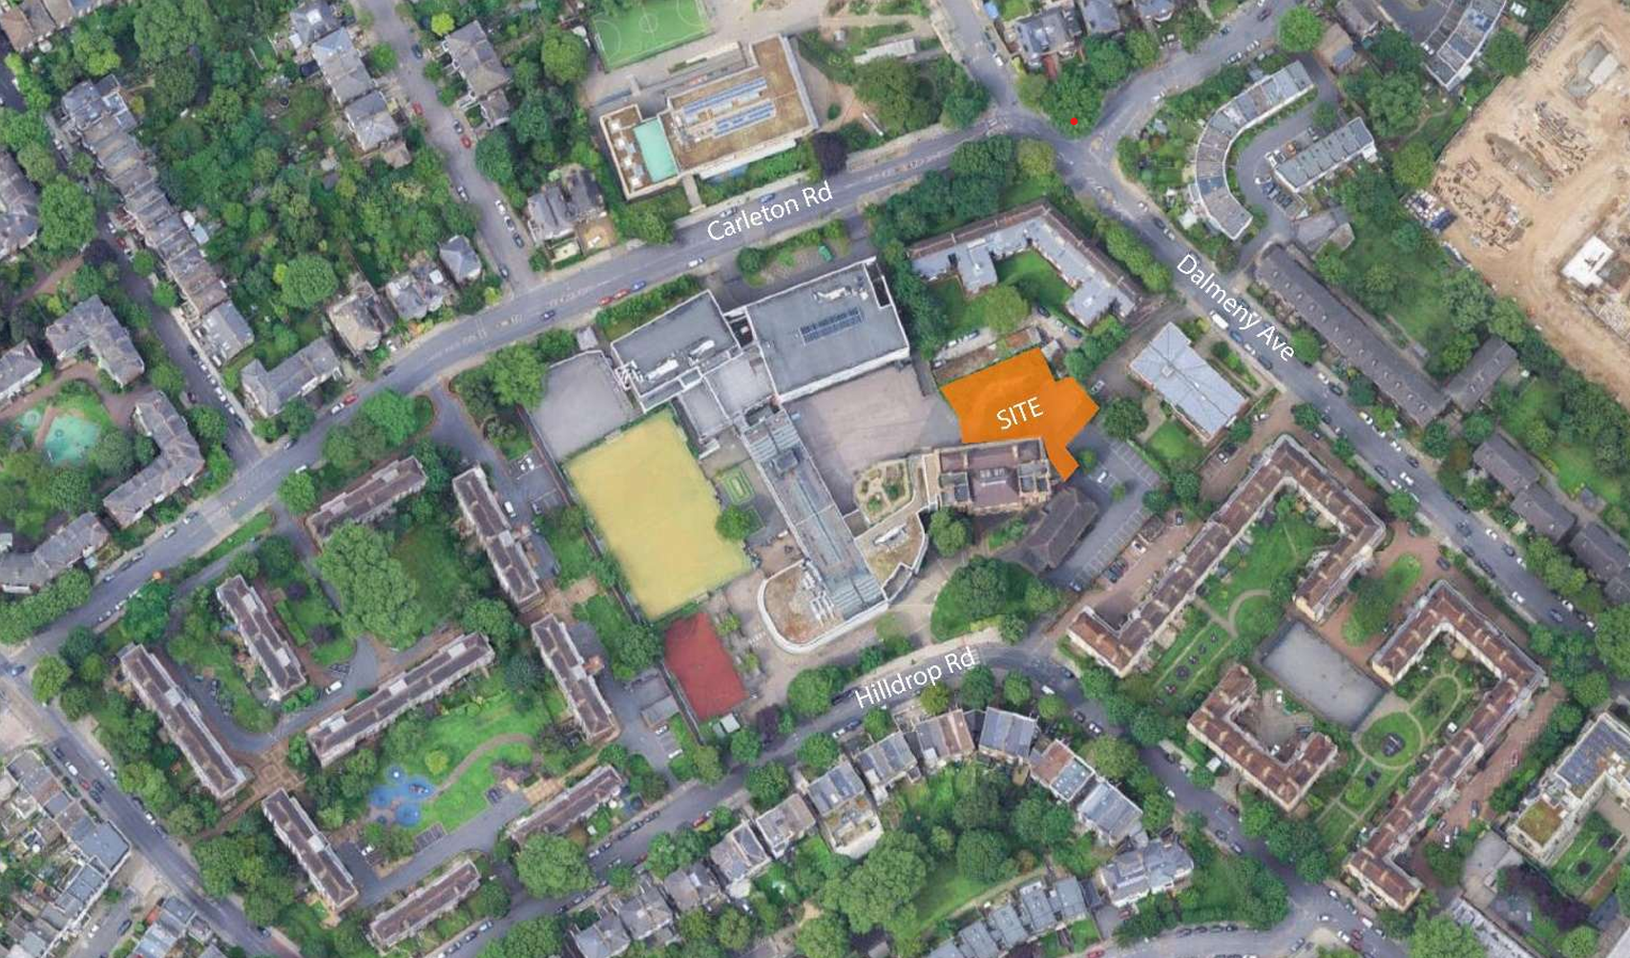

3. Risk Register
All members of the workforce will be required to comply with the significant findings of the project specific risk assessments as briefed by the PIC or their own supervisors.

Hazard/risk | Description | Controls
Fire | Use of flammable substances  Arson  Electrical Fire  Defective heaters, lighting, electrical equipment.  Hot processes such as welding, grinding, melting asphalt, naked flames cigarettes, matches and anything else that gets very hot or causes sparks. | - Fire Emergency Plan to be in place and communicated to the workforce. Regular updating of Fire Plan to reflect changing circumstances on site.  - Trained and competent operatives  - COSHH assessment undertaken and appropriate controls implemented and monitored by site management  - No storage of flammable substances is allowed on site  - No smoking on site a designated smoking area to be made available.  - Plan to reduce storage of combustible materials (e.g. just-in-time ordering)  - A hot permit to work must be in place before work commence following all safe system of work. Finish hot works 2 hours before end of shift.  - The cutting/welding, asphalting, area to be inspected prior to any work and exclusion zone and signage to be in place to keep away and warn unauthorised operatives  - The area will be swept of loose debris and materials or combustible materials adjacent to the working area will be removed.  - Fire extinguishers to be strategically placed into the hot work area.  - Extinguishers to be in date and equipment to be inspected before use.  - Suitable and sufficient fire points and means of fighting the fire.  - Early warning wherever possible, e.g. automatic detection and alarm.  - Minimum of two alternative escape routes.  - Avoid rubbish to be built up and arrange its removal regularly.  - All electrical equipment to be PAT Tested.  - Where LPG is used ensure burners are three metres away from cylinders and that hoses are reinforced with the correct connections to cylinders and appliances, flash and blow back arrestors.  - Do not store flammable materials nearby, use non-combustible sheets to protect surrounding surfaces and potentially combustible materials and to collect waste products for subsequent disposal.
Delivery and removal of materials (including waste) and work equipment | Contact with moving machines.  Explosion during unloading of or in the presence of flammable liquids or vapours.  Fall of material from forks or loaders/failure of lifting equipment.  Falls from vehicles.  Fire  Obstruction of emergency access routes & of areas normally dedicated to public use.  Overturn of vehicles or machines.  Slips trips, and falls.  Unloading in areas in use by the public.  Unauthorised access to the site / vehicles.  Weather.  High pressure hydraulic fluid ejection.  Manual handling.  Struck by material falling from height. | - All deliveries to be controlled by a banks man.  - No unauthorized personnel allowed when deliveries are taking place.  - Delivery personnel to be inducted / made aware of site / Client’s rules and procedures  - All areas exposed to fall from height hazards to be adequately protected.  - Site fire procedures to be in place and understood.  - No emergency access areas are to be obstructed, unless previously agreed with Client. In this case and alternative route needs to be established and adequately controlled.  - Only adequate and in good condition vehicles and equipment to be used on site. Only qualified / competent personnel to operate equipment.  - All waste materials will be carried by licensed carriers and disposed of at registered and licensed tip.  - Waste carrier’s licenses and transfer notes are retained.  - Special arrangements will be made for ‘hazardous’ waste, e.g. asbestos, as and when applicable.  - Materials and equipment to be delivered through routes defined by Client.  - No works to be undertaken under extreme weather conditions.  - Axis Europe have a management system in place for addressing waste  - Waste handling companies are used for controlled and hazardous waste  - Spillage kits are provided for site work  - Supervisors and foreperson to monitor on site housekeeping standards  Recycle empty cans
Traffic routes and segregation of vehicles and pedestrians | Vehicle and pedestrian movements  associated risks of injury from contact/collision with vehicles and pedestrian traffic  Map of the area to be inserted | - All trade personnel will receive information about the parking restrictions before commencement and during the induction  - Trade staff and visitors to obey local rules when driving, parking and moving around the local roads  - Appropriate PPE to be worn, boots, and hi visibility to be worn as mandatory.  Site supervisor and site foreperson to monitor and enforce driving and parking controls (sanctions to be taken against anyone breaching the site rules)  • Loading/unloading to be carried in designated area.
Dealing with services (water, electricity and gas) | Contractors will be allowed the free use of energy sources upon written application to the PIC, but it remains their responsibility to ensure proper use and the reporting of any defects.  The main hazards will relate to: hidden position, contact with live electricity, which can lead to shock, electrocution and Fire/explosion | - Only competent persons will undertake the electrical works.  - Permits to work will be issued to the operatives undertaking the works.  - Safe working system to be used when works are to be carried out around / on live services. Isolation and lock off kits used where necessary.  - There will be no working on live electrical services.  - All new services being installed will be controlled via a shutdown for final connections.  - There will be no entry to the area while the electrical isolations are taking place.  - As the works are outside there will be barriers in place to cordon off the electrical cupboard in the car park.  - PTW in use were necessary.  - Adequate supervision to be ensured.  - Cable locating devices to be used to locate possible live services. All cable locating devices will be used only by competent personnel.  - Information regarding buried cables provided by client or energy provider.  - All required service isolations must be coordinated with the School by the PIC
Falls from height | Falls from height or through fragile material of persons, tools, debris or materials, serious injuries or fatality  Falls from a podium tower due to unsafe working practices may lead to serious injuries  Falls due to incorrect choice of stepladder or incorrect working technique  Falls from MEWPS can lead to serious injuries | - Ladders/step ladders hop-ups will be EN131 or industrial category only  - Operatives will carry out pre user check to assess condition of equipment.  - Use only adequate and certified equipment and trained personnel to erect / dismantle work platforms.  - All faulty equipment will be removed from site.  - Safe System of Work to be used  - While operating MEWP’s  - All areas with the risk of fall from height to be adequately protected, using collective protection such as handrails. When not possible, operatives to use adequate PPE.  - All operatives to wear appropriate PPE, including safety harnesses and lanyards when required.  - Trailing cables to be run overhead or alongside traffic route.  - Equipment and materials to be stored safely away from traffic routes.  - Provision of clear signage and proper protection where obstructions are unavoidable. Adequate segregation to be ensured during scaffold erection / dismantling works.  - Provision of temporary sheet materials to cover uneven ground or floors and the reinstatement of all surfaces as soon as is practicable.  - Provision of temporary lighting where natural or existing lighting is insufficient for safe working.  - Removal of all waste materials and rubbish on a regular basis.  - Prevent falls, use access or safety equipment by competent persons.  - Ensure working area is suitable, level and free of debris.  - Avoid fragile surfaces, survey/inspect, safe system of work if unavoidable.  - Minimise distance/consequences of any fall, fit intermediate platforms to towers, use fall arrest equipment (if appropriate).  - Identify unsafe areas by signs and barriers; prohibit entry/access, police  - Handover/in-service and weekly inspection by competent persons.  - Good housekeeping standards to be maintained.  - Tools to be tethered whilst working at height.  - Monitoring of weather conditions and re-inspection appropriate  - Step ladders to be use only for light works  - Operatives to use the step ladder as per manufacturer instructions.  - Operatives will carry out pre user check to assess condition of equipment.  - Step ladders to be use for short duration works and short duration tasks.  - Maintain 3 points of contact with the ladder at all times.  - Ensure there is space to fully open and use any locking devices;  - Don’t work off the top three rungs of a ladder or top three steps for swing-back / double sided stepladders;  - Ensure that the step ladder is situated on a firm and even ground  - Ensure the step ladder is not obstructing the access/egress areas and it is stored out of the way whilst not in used.  - No overreaching when working from a step ladder.  - Operative to report faulty equipment and to be taken out of use with signage displayed.  - Never work under raised hydraulics unless they are fully supported by a correctly positioned and approved safety device (most commonly a safety prop).  - Never put any part of your body through or under a raised scissor stack unless it is fully supported by an approved manufacturer’s safety prop.  - If there is work to be conducted underneath the raised hydraulics and they cannot be supported by an “approved support device” a full assessment must be undertaken to identify all risks and specified control measures (in order to complete the work safely) MUST be mimplemented prior to the work being commenced.  - The operator MUST ensure that they are aware which is the front and which is the rear of the machine before activating the drive control lever to move the machine.  - In the case of Electric Scissor lifts, they must NOT be driven down a slope greater than 5 degrees and in the case of Diesel Scissor lifts they must NOT be driven down a slope greater than that specified in the manufacturer’s operating handbook.  - Ensure all audible and visual alarms are operational.  - Clearly define the work area.  - Keep all other personnel clear of the work area.  - Always remain within the confines of the platform.  - Never sit, stand or climb on the handrails.  - Never elevate the platform if the handrails have been removed.  - Never use ladders or scaffolding on the platform.  - Never enter or exit the platform whilst it is elevated.  - Ensure the deck is clean and in good condition.  Avoid oil, grease and mud on work boots.  - Maintain a clean platform, clear of rubbish and tools.  - Maintain a good foot and hand hold when climbing in and out of the platform.
Use of hand tools | (powered and non powered)  associated risks of injury through contact with moving parts and exposure to potential noise and vibration | - Guards are in place on all power tools used by staff  - Only skilled trade workers are using equipment on our projects  - Training has been provided to staff  - Appropriate PPE to be worn, boots, abrasion / cut resistant gloves and an FFP3 mask (if creating any form of dust) to be worn as mandatory.  - Inspection and maintenance regimes are in place with recorded data  - All electrically powered tools are regularly PAT tested  - Battery operated and reduced voltage (e.g. 110v) tools are used by trade staff  - Foreperson to ensure that tools are placed in safe location when not in use.  - During work activities, tools to be kept in the local area of the work  - Staff will be informed that tools must not be lent to residents and/or tools loaned from residents  - Trained first aiders to be available on site  Fully stocked first aid container to be available
Storage of materials | Include hazardous and non hazardous materials.  - Galvanised paint  - Portland Cement  - Silicone Sealant  - Emulsion Paint  - Oil Based Paints | - Where possible materials will be removed from site at the end of the working day.  - All materials will be carefully stored in accordance with the recommendations of the manufacturers and suppliers prior to use within the working area (s), or within secure storage container(s) in position(s) to be agreed with the Contract Administrator (or his agent) or they will be brought to site on a daily basis  - Any materials delivered on pallets must be stored no more than three high and positioned so as to facilitate safe access.  - Any materials delivered in sheet form are to be stored horizontally  - Materials are not to be stacked against the structure, plant or equipment. Support frames are to be used wherever possible and heights of stacks are to be kept to a minimum.  - Any loose materials stored on platforms, or in other similar areas, must not be allowed to fall accidentally. Toe-boards and / or other guards and physical barriers must be used.  - All materials that are deemed to be hazardous are stored in strict accordance with the recommendations of the manufacturer / supplier and that emergency measures are in place to deal with spillages or incidents.  - Contractors must ensure they maintain a full record of all materials that are deemed to be hazardous. Records must be forwarded to the PIC and copied to the Project Safety File.  - No storage of flammable substances is allowed on site  - COSHH assessments are available on site and brought to operatives attention.
Asbestos | The removal of asbestos  ACM,  Working with ACM  Accidental damage of ACM | All operatives working on site will be briefed as part of their induction the location and type of material which has been identified to contain the ACM’s  - All operatives will be asbestos awareness trained  - All operatives will be briefed on the accidental damage emergency procedure should they damage any of this material.  - Toolbox talks will be delivered.  - If material is damaged then the site manager must be informed and the area sealed off to prevent other persons being exposed.  - Clients asbestos register must be consulted before works can commence.
Manual Handling | Muscle injuries caused by Lifting, and carrying loads  Cuts & bruises caused by being hit by object being moved  Cuts & bruises from sharp edges  Incorrect Manual handling when carrying out material movement and unloading/loading tasks  Mechanical aids in poor condition may lead to them failing and causing injuries  Incorrect manual handling techniques  Environmental factors  Falling loads leading to bodily injuries  Moving loads repetitively leading to muscular injuries  Some operatives may have health conditions that affect their capacity to move or lift loads | - Eliminate or reduce manual handling as and when possible.  - Mechanical handling methods are to be used as and when possible  - Manual Handling and Toolbox talks delivered.  - Regular monitoring of onsite performance by contractor’s foreman and Axis PIC  - Appropriate PPE to be worn.  - Regular assessments to be carried out by PIC  - Any pre-existing conditions to be reported before starting a task, if at any time a operative feels unable to carry out a task, they must stop and call their supervisor/manager for assistance.  - Before carrying out manual handling operations the task is to be assessed for moving using mechanical aids  - Reduce weight of load where possible by breaking it down  - Stipulated safe working loads to be adhered to  - Operatives to be trained in their use and know how to report faults  - Specific assessments where there are repetitive or complex operations.  - The use of more than one person to move the load to be considered  - Lighting must be adequate  - Checks that floors are free from debris and that all obstacles are removed  - Working practices for women who may be pregnant to be reviewed  - Working practices for operatives who may have physical weaknesses or disabilities to be reviewed  - All mechanical aids to be checked and maintained on a regular basis  - Managing of lifting operations to be planned and carried out by competent persons (AP), provision of suitable lifting plans and RAMS to be provided and strictly adhered to, including thorough examination reports for all lifting equipment and accessories.  - All Lifting operations, including installation of timber hoarding posts, canopy posts, lighting columns, drainage inspection chambers etc. must be planned and carried out by competent persons. A lifting plan and RAMS is provided to be provided and copies of valid thorough examination reports will be available for all lifting equipment and lifting accessories.  All operatives involved in lifting are to carry out a self-assessment if required and will seek assistance to move the load. The following considerations should be made during the assessment; the weight of the load, how you would lift it, the environment you need to move it from/to, your ability to maintain a good posture (head up, straight back, no twisting).
Use of hazardous substances | List all hazardous substances  - Galvanised paint  - Portland Cement  - Silicone Sealant  - Emulsion Paint  - Oil Based Paints  - Solvent Cement | - Contractors are to conduct suitable and sufficient assessments in respect of the use of substances on this project. Copies of assessments are to be forwarded to the PIC and copied to the Project Safety File  - Contractors are to implement any control measures identified by the aforementioned assessment(s), reviewing, maintaining them and where appropriate testing them on a regular basis.  - Contractors are to ensure that they monitor the exposure of personnel under their control to hazardous substances and implement an appropriate programme of health surveillance where required.  - Information and training: All personnel under the control of contractors are to be provided with information, instruction and training in respect of any exposure to risks associated with hazardous substances.  - COSHH assessments/material safety data sheets for all COSHH items to be available on site and the guidance given within must be reviewed and implemented. The recommended storage arrangements must be co-ordinated and implemented ahead of receiving the materials to site.  - Monitoring and review: contractors are to monitor and conduct a formal review of their arrangements for controlling risk to health arising from exposure to any hazardous substances  - Disposal: contractors are to ensure that any waste involving hazardous substances is disposed of in accordance with the recommendations of the manufacturer or supplier to a facility licensed for this purpose.  - Records: Copies of all records required by Regulations and assessments made under the said regulations must be forwarded to the PIC and copied to the Project Safety File.  - Health surveillance regimes are in place (i.e. encounters undertaken by supervisors)  - Extraction systems to be used on power tools used to cut wood based products
Dust, fumes & smoke | Respiratory problems resulting from cutting, grinding, sweeping the floors, drilling etc.  Skin contact, some dust can cause ulceration of the skin and irritation or sensitisation of skin;  Eye contact -dust particles produced during the swiping process can cause eye Irritation/damage.  Inhaled dusts can get into the digestive tract, where they can cause local effects such as gastrointestinal tract irritation. | - Allow natural of use controlled wetting of the surfaces where possible to inhibit the creation of dust and release of fibres.  - Ensure PPE to include respirators, goggles or safety glasses.  - Ensure that dust, fumes and smoke minimisation control measures and techniques are followed by contractors. Note COSHH requirements.  - Use methods less likely to raise dust particles into the air such as chemical stripping or wet sanding  - Employees to maintain good standards of personal hygiene to avoid ingestion of dust via hand-to-mouth contact – washing facilities to be made available  - Operatives to ensure they assess the risk of dust arising from their work and appropriate control measurements to be taken.  - COSHH assessments to be available on site and brought to operatives attention.  - Dust and pollution shall be prevented, all measures are to be taken to prevent any nuisance to the general public and building occupier  - The right type of RPE and PPE to be used as per task been carried Damping down target area/ materials where the process permits it.  - All RPE masks must be face fit tested ensuring that they seal adequately to individual facial features, providing protection against hazardous airborne particles.  - Encouraging workers to work with care and instructing them how to control the dust produced by their work activities;  - A high standard of cleanliness to be maintained and replace the sweeping by using a vacuum cleaner.
Protection of the public, vulnerable groups and Interaction with residents | Vulnerable groups and others who will remain in the property during the work, plus others in the immediate vicinity of the work  associated risks of injury from contact/collision with material and tools left in the property, corridors and footpaths | - Axis Europe have previous experience of working in existing occupied premises  - Axis Europe ID cards are issued to all trade and management personnel  - Axis Europe staff all wear corporate clothing  - Staff are aware of their personal responsibilities to others  - Resident Liaison Officer is in place to identify early on any unique access issues that will need to be addressed  - Materials will be moved straight into the property to the local area and not left in pedestrian areas (staircases, landings etc.)  - Materials and equipment to be kept in localised area of the work away from general circulation areas inside the property  - If necessary liaison to be established with the vulnerable persons carers to assist in providing additional support to the occupants during the work  - Discussion to be held with the Client , family members and/or carers about identifying potential times when delivery activities should be avoided  - The natural features of each property to be used to keep residents away from the work in progress (e.g. closing the relevant room door where the work is taking place)  - Corex and other floor covering material to be taped down and checked at regular intervals by the trade work and the site foreperson  - Operatives will maintain all existing security measures during working time  - Working area will be segregated (where applicable) with barriers and signage to prevent unauthorised access  - Working area will be kept clear of trip hazards e.g. tools, materials and trailing cables
Reducing noise | Noise pollution will be likely during demolition/strip out/excavation works. | Plant, machinery and tools: contractors must ensure that they limit the generation of noise from any plant, machinery or tools used on this project to the lowest practicable level.  - Excessive noise levels: contractors must notify the PIC should they consider that excessive noise levels will be generated by their works in order that all practicable measures may be taken to reduce the exposure of any persons unrelated to the works. In this and in circumstances where the PIC considers that their works are generating excessive noise they will be required to carry out a risk assessment. Copies of the assessment and the results are to be forwarded to the PIC and copied to the Project Safety File. Where a risk assessment indicates that there is a risk to the health of employees who are or liable to be, exposed to noise; they must be placed under suitable health surveillance which should include hearing tests.  - Hearing protection: May only be used when all other measures are ineffective or unable to prevent exposure to noise, it must be made available upon request to any employee who is exposed to noise at or above a lower exposure action value.  - Hearing protection zones: Any area of any workplace where anyone is liable to be exposed to noise at or above an upper exposure action value must be designated a hearing protection zone and signed appropriately.  - Any noisy works will be coordinated with the School, giving consideration to environmental noise monitoring
Vibration |  | - Regulations: contractors will be responsible for ensuring that they comply with the requirements of the Control of Vibration at Work Regulations 2005 in so far as they may apply to their works and the personnel under their control.  - Plant, machinery and tools: contractors must ensure that they limit the generation of vibration from any plant, machinery or tools used on this project to the lowest practicable level.  - Ensure usage of adequate tools for the job and regular breaks and operative’s rotation.  - Regular inspections and maintenance to be ensured.  - Regular medical surveillance, when required.  - Vibration exposure to be managed and monitored through Hand-Arm Vibration Syndrome (HAVS) assessments for power tools and equipment e.g. breakers, petrol disc cutters, wacker plates or monitoring of operative trigger times
Temporary Works |  | - Billy Williams, The Temporary Works Coordinator (TWC) is appointed to manage any temporary works on site. A temporary works risk register detailing the temporary works items will be maintained on site with any design drawings and calculations and regular recorded inspections of any temporary works items permanently erected e.g. heras fencing, trench support systems to be carried out
Ground Works/Excavations |  | - All excavations must be supported, battered or stepped, no materials or plant shall be stored at the edge of any excavated areas. Excavations to be barriered off with warning signage displayed, and where practical backfilled at the end of shift and or covered. Suitable access to be provided into excavations. Daily recorded inspections to be undertaken
- Tree protection and root protection zones will be established in accordance with the Arboricultural survey findings and ensure that appropriate control measures as per the report recommendations are implemented.
- Ensure works accord with the recommendations and the British Standard-BS 5837-2012_Trees in relation to design, demolition and construction.
- The schedule of supervision, in section 4.0 of the Arborcultural report (by Lizard Landscape Design and Ecology, ref LLD3799), must becompleted and updated after each of the supervised working practices.
- Photographic evidence shall be taken at each stage and will be recorded in the next corresponding response and supervision document.
- All tree protection fencing, TPF, and ground protection to be installed in line with the drawing- 1ST HORIZON- Tree Protection Plan. All Tree Protection
- Barriers to be in accordance with- BS 5837:2012 - 'Trees in Relation to Design, Demolition and Construction - Recommendations'. Where TPF needs to be installed within a Root Protection Zone RPA, this will need to be erected on non-ground penetrating feet. Appropriate signage, must be affixed to all sections of TPF.
- Behind the fencing, there will be no unauthorised vehicular access; no repeated pedestrian access; no fires; no storage of excavated debris, building materials, chemicals, or fuels; no mixing of cement; no service installation or excavation; no raising or lowering of soil levels; and no excessive cultivation for landscape planting.
- The following sections of BS 5837:2012, will be implemented.
6.2.1.5- The supervising arboriculturist should confirm that the tree protection has been installed as agreed before any significant site work starts.
      - The tree protection should be fit for purpose, i.e. preventing inappropriate work in the RPAs of retained trees, and be maintained to remain rigid and complete.
    - Where structures are to be removed from RPAs, fencing and ground protection should be installed up to the edge of the structure to protect theunderlying soil.
- Ground Protection will need to be in place in any areas of RPA which are outside of the specified TPF locations. Additional Ground Protection materials must be present on site to ensure any further protection needs can be met during inspection visits from the project arboricultural consultant.
- All Ground Protection must be fit for the expected level of traffic for the duration of the construction period, in accordance with BS 5837:2012 - 'Trees in Relation to Design, Demolition and Construction - Recommendations'.
Light, Moderate and Heavy-Duty Ground Protection Access Mats of Medium/
Heavy Density Polyethylene (HDPE) are recommended to be present on site.

Waste Management Plan

All waste and debris created from work activity shall be handled in accordance with this WMP. All staff working on this contract should be aware of the requirements listed below.

Responsibilities | Name | Number
Site/Contract specific contact for waste | Mick Moran | 07887702587
Company wide contact for waste | Ned Maynard | 0203 597 2185
Who submits Waste Transfer Notes | Mick Moran | 07887702587

All general building waste to be removed and stored in the skip within the site compound until collected and disposed of by Reconomy Connect Skip Hire.
Excavated material to be stored and then disposed of by wait and load waste removal contractor – employed by Firt Choice (Groundworks contractor)
Any licensed ACM’s to be removed and disposed of by licensed asbestos removal contractor.

Health and Safety File (O&M Manual)

The health and safety file is defined as a file appropriate to the characteristics of the project, containing relevant health and safety information to be taken into account during any subsequent projects. The file must be prepared by the Principal Designer.
This information must be provided by all contractors involved in the project and must be presented to Axis Europe as soon as the works complete.
Axis Europe must collate all the relevant information and present it to the PD in a timely manner in the format requested by the Client.
The file must contain information about the current project likely to be needed to ensure health and safety during any subsequent work, such as maintenance, cleaning, refurbishment or demolition. When preparing the health and safety file, information on the following should be considered for inclusion:
- A brief description of the work carried out
- Any hazards that have not been eliminated through the design and construction processes, and how they have been addressed (e.g. surveys or other information concerning asbestos or contaminated land)
- Key structural principles (e.g. bracing, sources of substantial stored energy – including pre or post tensioned members) and safe working loads for floors and roofs
- Hazardous materials used (e.g. lead paints and special coatings)
- Information regarding the removal or dismantling or installed plant and equipment (e.g. any special arrangements for lifting such equipment)
- Health and safety information about equipment provided for cleaning or maintaining the structure
- The nature, location and markings of significant services, including underground cables, gas supply equipment, fire fighting services etc.
- Information and as built drawings of the building, it’s plant and equipment (e.g. the means of safe access to and from service voids and fire doors)
- Hazards in dismantling or demolition

Appendix 1- Summary of roles and duties under CDM Regulations 2015
CDM Duty holder | Summary of role/main duties
Clients are organisations or individuals for whom a construction project is carried out | Make suitable arrangements for managing a project. This includes:  - Other duty holders are appointed  - Sufficient time and resources are allocated  Make sure  - Relevant information is prepared and provided to other duty holders  - The principal designer and principal contractor carry out their duties  - Welfare facilities are provided
Designers are those, who as part of a business prepare or modify designs for a building, product or system relating to construction work | When preparing or modifying designs, to eliminate, reduce or control foreseeable risks that may arise during  - Construction and  - The maintenance and use of a building once it is built  Provide information to other members of the project team to help them fulfil their duties
Principal Designers are designers appointed by the client in projects involving more than one contractor. They can be an organisation or an individual with sufficient knowledge, experience and ability to carry out the role | Plan, manage, monitor and coordinate health and safety in the pre-construction phase of a project  This includes  - Identifying, eliminating or controlling foreseeable risks  - Ensuring designers carry out their duties  Prepare and provide relevant information to other duty holders  Provide relevant information to the principal contractor to help them plan, manager, monitor and coordinate health and safety in the construction phase
Principal contractors are contractors appointed by the client to coordinate the construction phase of a project which involves more than one contractor | Plan, manage, monitor and coordinate health and safety in the construction phase of a project. This includes  - Liaising with the client and principal designer  - Preparing the construction phase plan  - Organising cooperation between contractors and coordinating their work  Ensure  - Suitable site inductions are provided  - Reasonable steps are taken to prevent unauthorised access  - Workers are consulted and engaged in securing their health and safety  - Welfare facilities are provided
Contractors are those who do the actual construction work and be either an individual or a company | Plan, manage and monitor construction work under their control so that it is carried out without risks to health and safety  For projects involving more than one contractor, coordinate their activities with others in the project team – in particular, comply with directions given to them by the principal designer or principal contractor  For single contractor projects, prepare a construction phase plan
Workers are the people who work for or under the control of contractors on a construction site | They must  - Be consulted about matters which affect their health safety and welfare  - Take care of their own health and safety and others who may be affected by their actions  - Report anything they see which is likely to endanger either their own or others health and safety  - Cooperate with their employers, fellow workers, contractors and other duty holders

Appendix 2- Site Rules

- Upon arrival, report to site office, sign in and attend site safety induction.
- Axis IDs and corporate clothing must be worn at all times.
- Attend all Toolbox talks when requested by Site Manager.
- Do not put yourself or others at risk.
- Appropriate PPE to be worn at all times.
- Permission must be obtained from Site Manager prior starting any work on site.
- All accidents/incidents/near misses must be reported to Site Manager who will record the event in the site accident book.
- Consumption of alcohol or illegal substances on the site or in the working area(s), or being under their influence is prohibited. Known side effects from drugs prescribed by a GP must be notified to the Site manager.
- Radios or personal audio devices (such as iPods) are not to be used.
- RAMS and COSHH assessments are to be signed by operatives.
- Offensive or inappropriate language and provocative gestures are not allowed.
- Access routes and working areas are to be kept clean and clear of vehicles / materials / debris.
- No smoking permitted on site or offices and will only be allowed only in designated areas outside the Estate.
- Your attention is drawn to the Fire Safety Plan displayed in the Site Office and Canteen.
- Safety signs and notices must be followed. Emergency evacuation routes must not be obstructed at any time.
- The workforce must only use BS131 or Class1 ladders that are in good condition, tied and extend beyond the step off point in the proper manner.
- All debris or waste must be cleared at the end of the day or shift and their working areas to be kept tidy.
- Your attention is drawn to our Construction Logistics Plan / TMP and the rules contained therein in particular regarding material deliveries / muck awa
- Copies of waste transfer/carriage notes and a copy of the carrier’s license must be forwarded to the Site Manager and copied to the Project Safety File. Potentially hazardous waste must be removed and disposed of in strict accordance with the recommendations of the manufacturer / supplier.
- Sign out and return PPE upon leaving.

Appendix 3 – Fire Evacuation Plan
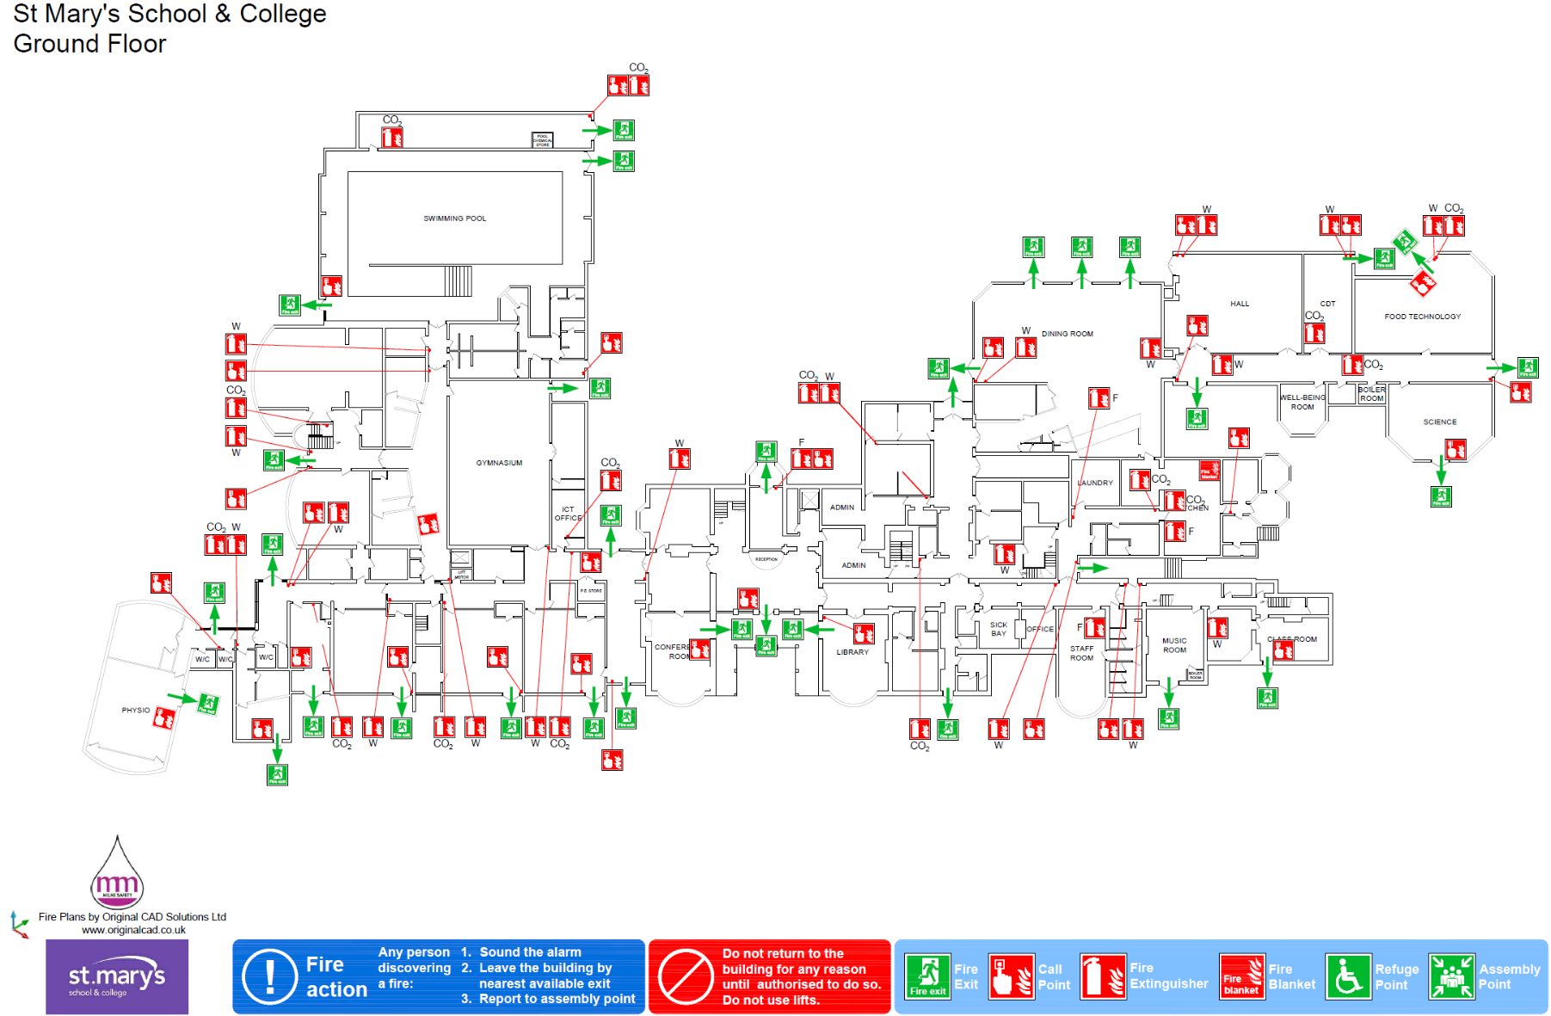

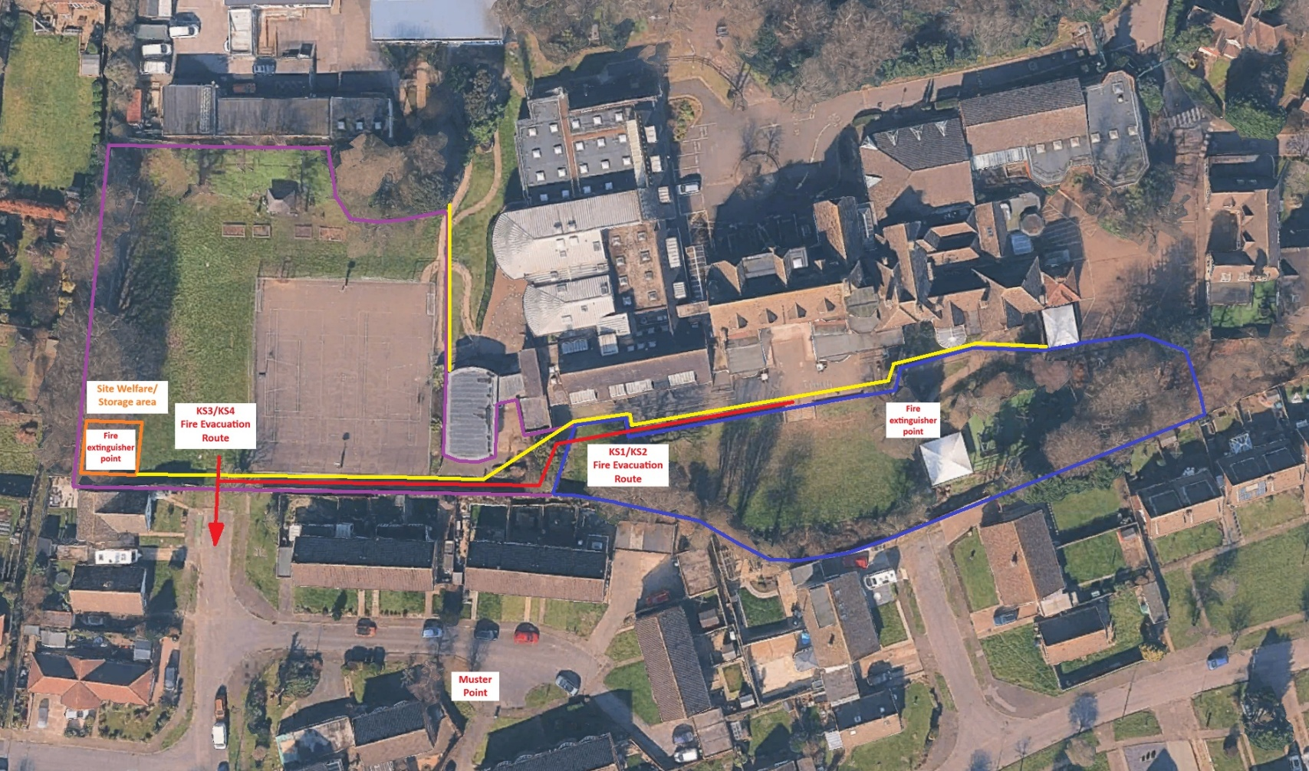
Appendix 4 – Site Fire Evacuation Plan

- In the event of a fire, exit the site via the rear gate in the KS3/4 area, leading on to Chatres Close, as marked with the red arrow on the above image.
- All persons exiting the site should turn left on Chatres Close and gather at the Muster Point as shown on the above image, keeping clear of emergency vehicle routes.
- Do not return t the site for any reason until the PIC has given authorisation to do so.

